A Decomposition Based Multi-objective Particle Swarm Optimizer for Constraint Handling
Weikang Ning, Baolong Guo, Yunyi Yan, Jinfu Wu, Dan Zhao
(School of Aerospace Science & Technology, XidianUniv., Xi’an 710071, China;)

Abstract: Multi-objective particle swarm optimization (MOPSO) algorithms based on decomposition have drawn a lot attention recently. Despite the success of decomposition based MOPSO (MOPSO/D) algorithms, its use in constrained multi-objective optimization problems (CMOPs) remains to be further studied. Most MOPSO/D algorithms proposed recently are designed for unconstrained problems. Thus we aim to extend the ability of MOPSO/D algorithms in our study. A framework of decomposition based MOPSO for constraint handling (cMOPSO/D) is first proposed in this paper. Then two typical constraint handling techniques are combined with cMOPSO/D as a comparison, which results in two versions of cMOPSO/D: cMOPSO/D using penalty function (cMOPSO/D-P) and cMOPSO/D using lexicographic ordering (cMOPSO/D-LO). The algorithms proposed are tested on ten CMOPs and are compared with three state-of-the-art algorithms, cMOEA/D, D2MOPSO and OMOPSO. Experimental results supported by the statistical analysis of three quantitative metrics, together with some theoretical analysis, suggest that the proposed algorithms are effective, competitive and promising.
Keywords: Multi-objective optimization, Decomposition, PSO, Constraint handling, Penalty function, Lexicographic ordering

Introduction
As a paradigm of evolutionary algorithm (EA), particle swarm optimization (PSO) has been successfully applied to solving multi-objective optimization problems (MOPs)[22,20,11]. In the real world, however, many problems to be solved often need to satisfy several equality and/or inequality constraints, and this presents an additional challenge for multi-objective evolutionary algorithms (MOEAs). Solving constrained multi-objective problems (CMOPs) ideally often requires the search making a balance between the feasible and infeasible regions, thus the information carried by the infeasible solutions could be fully exploited.
Many constraint handling techniques are proposed and have been studied for a long time in single objective optimization[7,13]. Penalty function is widely used for its simplicity [28,18,33,2]. The fitness of a solution is calculated based on its objective value and a penalty term. But how to determine the amount of penalization is rather hard. To alleviate this drawback, some adaptive penalty functions are reported in the literature [17,8,3,5]. Besides, different constraint handling techniques based on lexicographic ordering are also widely studied. Deb[9] proposed a binary tournament selection operator to compare two solutions. Based on the satisfaction level for the constraints, Takahama and Sakai proposed an α constrained method

[29] that uses α level comparison to compare two solutions. As an improvement of α con-strained method, ε constrained method, which was proposed by Takahama and Sakai [30], adopts an ε level comparison to
compare two solutions. A dynamic control of ε was also proposed and the comparison scheme was combined with PSO. Because it is hard to strike the right balance between the objective andthe penalty term in penalty functions, Runarsson and Yao[23] proposed a statistic ranking method in which the constraint violation is ignored with some probability.
In relatively traditional Pareto dominance based MOEAs, constraint-dominance is a widely used constraint handling technique. Inspired by the binary tournament selection operator [9] used in constrained single objective optimization, a constraint-dominance relationship was proposed by Deb [10] in NSGA-II to compare two solutions. Similar constraint handling strategies are adopted by MOPSO [6] and OMOPSO [27]. Besides, penalty function based constraint handling techniques are also used. An adaptive penalty based constrained handling technique was incorporated with non-dominated sorting by Woldesenbet [32]. In this method, each objective value of a solution is modified first based on its constraint violation and then non-dominated sorting is used.
The concept of decomposition, which was proposed by Zhang[37] recently, has proven to be efficient in handling many complex MOPs. The fitness assignment mechanism adopted by multi-objective evolutionary algorithm based on decomposition (MOEA/D) makes it easier for MOEA/D to incorporate many constraint handling techniques originally invented for single objective optimization. Jan and Zhang[14] proposed a penalty function based MOEA/D for constraint handling. The penalty function adopted uses an adaptive threshold to control how heavy an infeasible solution is punished. Besides, two lexicographic ordering based MOEA/D are also reported. Asafuddoula[4] introduced an allowable violation threshold to determine if an infeasible solution is considered as feasible. The threshold is adaptively determined and lexicographical ordering is used to compare two solutions. More recently, Mart´ıez and Coello[36] proposed a constraint handling MOEA/D based on ε constrained method[30]. The method introduces a modified ε level comparison with an adaptively adjusted parameter ε. Besides, another parameter is introduced to tackle the “ε level comparison drift” problem. The three methods listed above all introduce a threshold to make sure that the solutions with relative low constraint violation degree are well utilized, thus making a balance between the search of feasible and infeasible regions.
Recently, decomposition based multi-objective particle swarm optimization (MOPSO/D) has drawn a lot attention. Several algorithms such as MOPSO/D [21], dMOPSO[34] and D2MOPSO[1] have been proposed. Proposed by Peng and Zhang, MOPSO/D¹ adopts the basic framework proposed in MOEA/D but replaces the genetic operators by flight equations used in PSO. Proposed by Mart´ıez and Coello, dMOPSO adopts a new gbest update procedure with a high selection pressure and memory re-initialization of a particle is adopted to provide diversity to the swarm. Recently, Moubayed proposed a hybrid approach of dominance in D2MOPSO. Decomposition is used to transform a MOP into a set of subproblems while dominance is used to build the leaders’ archive. The selection pressure is obtained by using the aggregation value as the selection criteria. The research of constraint handling techniques in MOPSOs based on decomposition is, however, still relatively scarce. Among these algorithms listed above, MOPSO/D¹ and dMOPSO are both designed for unconstrained MOPs while D2MOPSO uses constraint-dominance to tackle the constraints.
This paper aims to provide a comparative study of two typical constraint handling techniques that are combined with the proposed decomposition based MOPSO framework: decomposition based MOPSO for constraint handling (cMOPSO/D). First, the cMOPSO/D framework proposed uses a global best population(gBest) to store the best solutions (selected using a rule of comparison that takes both the aggregation value and the constraint violation degree into consideration) found for each subproblem. A global leader is selected for each particle from gBest using the aggregation value as a criteria. Besides, a crowding archive is used to store the feasible and non-dominated solutions encountered during the search, which can help to prevent the loss of good solutions. Second, two constraint handling techniques are introduced as a comparative study and they are combined with cMOPSO/D, which results in two versions of cMOPSO/D: cMOPSO/D using penalty function (cMOPSO/D-P) and c-MOPSO/D using lexicographic ordering (cMOPSO/D-LO). A penalty function with an adaptive threshold is used in cMOPSO/D -P to tackle the constraints, the form of which is similar to the one used by Jan and Zhang[14]. cMOPSO/D-LO uses lexicographic ordering with an allowable constraint violation, which is similar to the one used by Asafuddoula[4]. The adaptive threshold adopted in cMOPSO/D-P and cMOPSO/D-LO makes sure the balance between the feasible and infeasible regions. The constraint handling techniques proposed in this paper differ from Jan’s and Asafuddoula’s mainly in the way in which the threshold is adjusted.
The remainder of this paper is organized as follows. Section 2 provides some basic concepts of constrained multi-objective optimization and PSO. Section 3 provides a detailed explanation of the proposed cMOPSO/D framework and the constraint handling techniques that are incorporated. Then, experimental studies and analysis are presented in section 4. Finally, section 5 concludes this paper.

2. Related backgrounds

2.1 Constrained multi-objective optimization problems
Without loss of generality, a constrained multi-objective problem (CMOP) could be stated as:
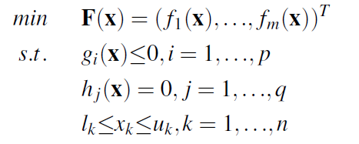(1)
where is an n dimensional decision vector lies in the decision space , are p inequality constraints, and are q equality constraints. , are the lower and upper bounds of . The set of solutions that satisfy all the constraints of problem (1) defines the feasible region Ω⊆. F: Ω→ consists of m objective functions (,...,)to be minimized and is called the objective space.
In solving a MOP, the improvement of one objective often leads to the deterioration of another. Thus multi-objective optimization algorithms aim to find the best trade-offs among the objectives. The best trade-offs among different objectives can be defined using the concept of Pareto optimality.
In a minimization problem, a domination relationship between two solutions could be defined as follows: let x, y∈Ω, xy if and only if for every i∈{1,...,m} and for at least one j∈{1,...,m}. A solution is called a Pareto optimal solution if there is no other solution ∈Ω such that . The set of all the Pareto solutions in Ω is called the Pareto set(PS) and its image in the objective space is call the Pareto front (PF)[22].

2.2 Tchebycheff approach
In MOEA/D, the original MOP could be decomposed into a number of scalar optimization problems using different scalar approaches[37]. Among them is Tchebycheff approach that is widely used.
Tchebycheff approach: decomposes a MOP into different scalar optimization problems, and the scalar optimization problem is of the form:
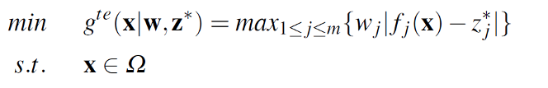(2)
where Ω is the feasible region, = is the reference point and =min{|x ∈ Ω} (j= 1,...,m), =(,...,) is a weight vector, i.e., ≥ 0 for each j∈{1,...,m} and =1. is also called the aggregation value of solution .

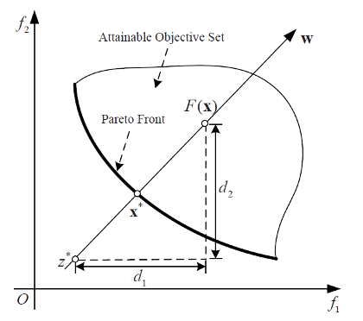
Fig. 1. Illustration of the Tchebycheff approach

For each Pareto optimal point there exists a vector w such that is the optimal solution of (2) and each optimal solution of (2) is a Pareto optimal solution of (1). Therefore, one is able to obtain the appropriate presentation of the Pareto front by a set of well-distributed weighted vectors.
As is shown in Figure 1, is a weighted vector, the aggregation value of solution is =max{,}.By minimizing , the Pareto optimal solution along the direction defined by could be found.

2.3 Constraint violation degree
The over all constraint violation degree V(x) of a solution x can be simply defined as:
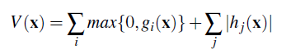 (3)
In practice, the equality constraints are often transformed into inequality constraints using:
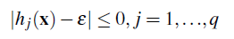 (4)
where ε is a small real-value threshold given by the user.
By this way, a CMOP as is defined in (1) can be transformed into a CMOP with only inequality constraints. So the constraint violation degree V(x) defined in (3) could be simplified as:
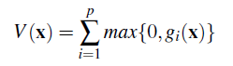 (5)

2.4 Basic PSO concept
Originally proposed by Kennedy and Eberhart[15], PSO is a population-based metaheuristic search algorithm that simulates the social behavior of birds within a flock. In PSO, the position of each particle is changed according to the best position visited by its own and the global best position produced by the swarm. Let denote the position of particle at step t. The position of could be changed based on the following rules [22]:
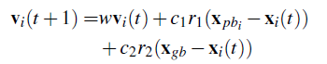 (6)
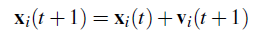 (7)
where w is the inertia weight, is the cognitive learning factor and is the social learning factor, ,∈[0,1] are random values. is the speed of particle at step t, is the best position visited by particle pi and is the best position visited by the swarm.

2.5 Crowding archive
In Pareto dominance based MOEAs such as SPEA [40] and NSGA-II [10], an external archive is widely used to store the non-dominated solutions encountered during the search. The archive is updated continuously and is often used to lead the search.
The archive adopted is often bounded in size because of limited computational resources. Thus different strategies have been proposed to maintain the archive. An experimental study of three different archiving methods is carried out by Padhye[19] and some typical crowding distance based archiving methods are briefly surveyed by Moubayed[1].

3.The proposed algorithm
In this section, the basic idea of cMOPSO/D is firstly introduced. Then the constraint handling techniques that are combined with the framework and the general framework of cMOPSO/D are detailed in subsequent subsections.

3.1 Basic idea of cMOPSO/D
Recent years have witnessed a great success in combining some typical constraint handling techniques for single objective optimization with MOEA/D. However, the study of combining MOPSO/D with these techniques is still scarce. This subsection describes some core issues while designing cMOPSO/D.
One core issue of MOPSO/D is maintaining the personal best population pBest and the global best population gBest. For unconstrained MOPSO/D, two solutions could be compared with each other based solely on their aggregation values. For constrained MOPSO/D, however, two solutions should be compared with each other based on a rule of comparison that takes both the aggregation value and the constraint violation degree into consideration. Different constraint handling techniques define different rules of comparison. In our study, two typical constraint handling techniques (penalty function based constraint handling and lexicographic ordering) that are widely used in single objective optimization are introduced into MOPSO/D as a comparative study, thus resulting in two versions of cMOPSO/D, cMOPSO/D-P and cMOPSO/D-LO. Though different rules of comparison are used in these two constraint handling techniques, they both adopt a constraint violation threshold to balance the search between optimality and feasibility. While updating pBest or gBest, a constraint violation threshold is calculated first and then is passed to a comparator, which is used to select the better solution from two solutions. In the proposed cMOPSO/D framework, the constraint violation threshold is calculated based not only on the solutions in the swarm but also on the best solutions (the solutions in pBest or gBest). The same constraint violation threshold is used in the comparators adopted by cMOPSO/D-P and cMOPSO/D-LO. The comparators adopted in cMOPSO/D-P and cMOPSO/D-LO are detailed later in this section.
Since PSO is characterized as an algorithm with high convergence rate, a re-initialization mechanism of the best solutions in pBest and gBest is introduced to improve the diversity of the swarm.
Another core issue of MOPSO/D is selecting the best leaders while updating the velocity of a particle. The leader selection strategy could influence the search process significantly. In the proposed cMOPSO/D framework, the global leader for a particle is selected from gBest based on the aggregation value,which aims to introduce a high selection pressure.
Besides, an external crowding distance archive is used to store the feasible and non-dominated solutions encountered during the search. The archive adopted aims to prevent the loss of optimal feasible solutions encountered during the search.

3.2 Constraint violation threshold in cMOPSO/D
The balance between optimality and feasibility in the search process is important while solving CMOPs.
Different constraint handling techniques may adopt different ways to achieve the balance. For constraint handling techniques based on penalty function and lexicographic ordering, one way of achieving the balance is by introducing a constraint violation threshold into the comparator as an additional parameter. And an adaptive strategy that utilizes the feedback of the search process to adjust the parameter is often adopted because of its effectiveness. Some adaptive strategies are adopted in [14,4,36]. When two solutions are compared with each other using a comparator that uses a penalty function with a constraint violation threshold, the solution with greater constraint violation degree than the threshold is assigned a much greater penalty term. When two solutions are compared with each other using a comparator that uses lexicographic ordering with a constraint violation threshold, the solution with less constraint violation degree than the threshold is considered as feasible. By doing this, the solution with less constraint violation degree than the threshold will have a greater chance of being retained in the population. When combining theses two constraint handling techniques with MOPSO/D, the constraint violation threshold should be calculated more carefully to make a better balance. The way in which the threshold is adjusted then becomes a core issue.
In cMOPSO/D, the comparison between two solutions takes place when pBest or gBest is updated(refer to step 16 of algorithm 2 and step 5 of algorithm 5 that are presented later). Two different comparators are used in cMOPSO/D-P and cMOPSO/D-LO but the constraint violation threshold is calculated in the same way.
When pBest (gBest)is updated, the constraint violation threshold () is first calculated based on and pBest (gBest), as is shown in algorithm 1. Notice that while calculating (), and xBest in algorithm 1 should be replaced by () and pBest(gBest), respectively. B(i) denotes the indexes of all neighboring problems of the ith subproblem and it is calculated in step 2 of algorithm 3.
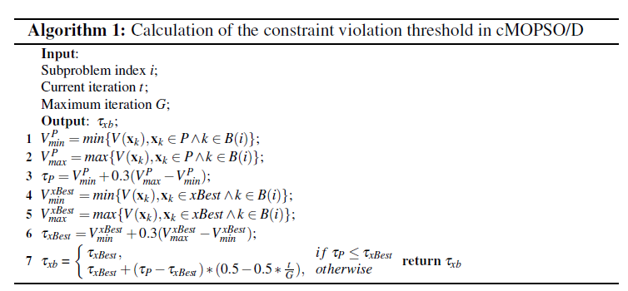
In our study, the solutions in the swarm and the solutions in the best population are both considered while calculating the constraint violation threshold. Since the solutions in pBest and gBest are the better solutions selected using a comparator, the solutions in the best population will generally have lower constraint violation degree than the newly generated solutions in the swarm. At an early stage of evolution, the constraint violation threshold is assigned a larger value considering both the solutions in the best population and the swarm, which gives the solutions with lower constraint violation degree a higher chance of entering the best population. The calculation of the constraint violation threshold relies more and more on the best population with evolution, which aims to find more feasible solutions.
Once the constraint violation threshold has been calculated, it could be used as a parameter of the comparators that are described in the next two subsections.

3.3 Constraint handling using penalty function
cMOPSO/D-P uses a penalty function with a constraint violation threshold to tackle the constraints. The penalty function adopted in this paper is similar as the one adopted by Jan and Zhang [14], which is of the following form:
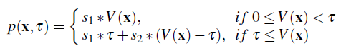 (8)

where and are two scaling parameters, is the constraint violation degree calculated according to equation 3 and τ is the constraint violation threshold that is calculated according to the previous subsection.
Comparator Compare(,,,,τ) is used in cMOPSO/D-P to compare two solutions and . Compare(,,,,τ) returns true if:
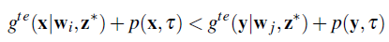

where is the aggregation value of solution and it could be calculated based on equation 2, and are two weight vectors, is the reference point, p(,τ) is the penalty term of solution and τ is the constraint violation threshold.

3.4 Constraint handling using lexicographic ordering
cMOPSO/D-LO uses lexicographic ordering with a constraint violation threshold to tackle the constraints.
Comparator Compare(,,,,τ) is used in cMOPSO/D-LO to compare two solutions and . Compare(,,,,τ) returns true if:
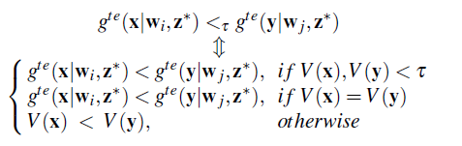 (9)

where is the aggregation value of solution and it could be calculated based on equation 2, and are two weight vectors, is the reference point, is the constraint violation degree of solution and τ is the constraint violation threshold.

3.5 General framework of cMOPSO/D
The proposed cMOPSO/D framework for multi-objective optimization employs the concept of decomposition proposed in MOEA/D[37].Thus a set of N well-distributed weight vectors W = {,...,} is previously given. The CMOP to be solved then could be decomposed into N subproblems using Tchebycheff approach and each weight vector in W. The ith subproblem is defined by and it is solved using the information of its neighborhood. B(i) denotes the indexes of T nearest (based on Euclidean distance) neighboring weight vectors belonging to (i= 1,...,N).
Initially, a swarm = {,...,} of N particles is randomly initialized and the speed of each particle is set to zero. At each generation, each particle tries to minimize the ith subproblem defined by (i= 1,...,N).
In cMOPSO/D, the ith particle in the personal best population pBest is used to store the best position found by each particle . And the ith particle in the global best population gBest is used to store the best position found by the particles that have a neighborhood relationship with . Initially, pBest and gBest are both set to . By a best position in pBest and gBest is meant a solution selected using the comparators described previously.

At each cycle, pBest and gBest are utilized to update the velocity and position of each particle according to equation 6 and 7, respectively. For particle , its personal best leader is while its global best leader is selected according to algorithm 4, which introduces a high selection pressure.
After the position of particle has been calculated, a polynomial mutation operator is implemented on with a given probability pm to improve the diversity of the swarm.
Once the new position of a particle has been achieved, it is checked to ensure it lies inside the bounds of the problem. The position of particle is checked according to equation10 [34,1].
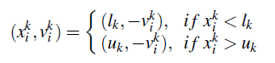 (10)
where is the kth component of the new position , is the kth component of velocity , and are the lower and upper bounds of the kth decision variable within the decision vector.
The repaired solution is then evaluated and used to update the reference point .
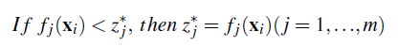 (11)
The new position is also used to update pBest and gBest. While comparing two solutions, the rule of comparison is implemented by the comparator Compare(,,,,τ) that is detailed in the previous subsections.
In cMOPSO/D, the age of a best solution in pBest (gBest)is defined as the number of consecutive iterations that the solution is not updated. pBestAge records the age of each solution in pBest and it is updated while updating pBest. In line 21 of algorithm 2, the personal best solution is replaced using the DE operator when its age has reached ageThres. For the DE operator to work, two different parents are selected from gBest randomly and a third parent is selected as . Similarly, gBestAge records the age of each solution in gBest and it is updated according to algorithm 5 and 6.To replace using DE operator in line 8 of algorithm 6, two different parents are selected from gBest randomly and a third parent is selected as . The DE operator adopted improves the global search ability of cMOPSO/D.
Finally, if the new solution xi is feasible, insert it into the crowding archive CrowdingArchive that is used to store the feasible and non-dominated solutions.
Algorithm 2 presents the general framework of cMOPSO/D proposed in this paper.
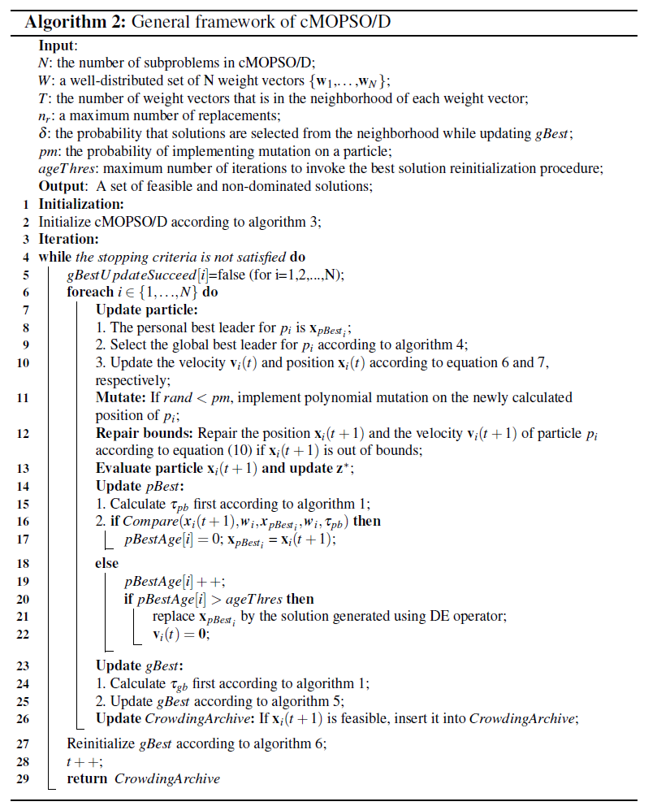

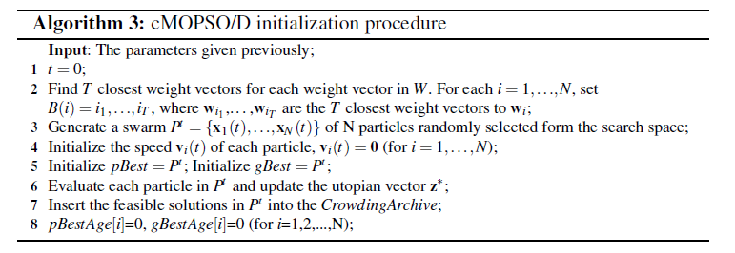

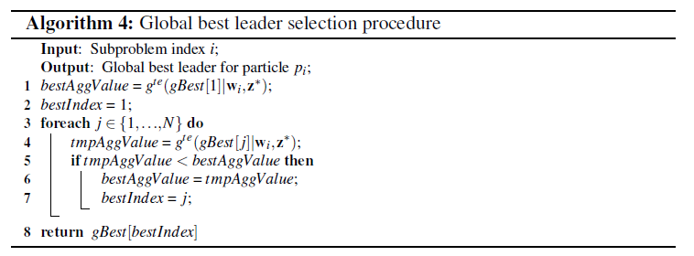
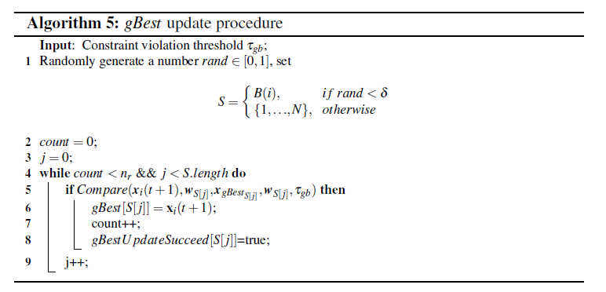
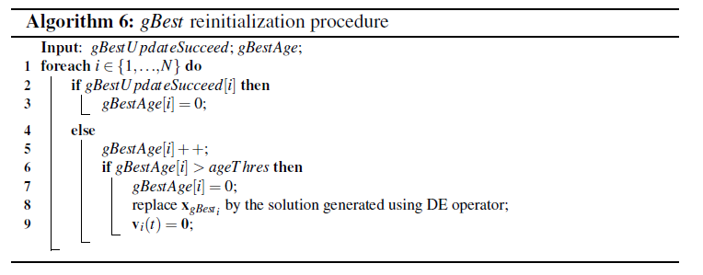

4. Experimental study

4.1 Test problems and performance metrics
The performance of cMOPSO/D is tested on ten CMOPs of CEC’2009 test suite, which is proposed by Zhang [38].Table1presentsa brief summary of the problems used. The details of these problems could be found in [38].

Table 1. Test problems
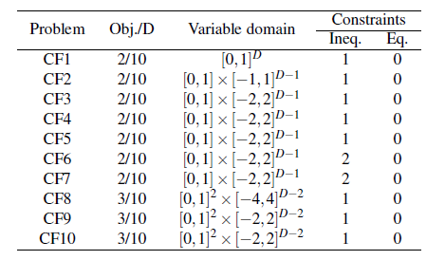
Proposed by Zitzler [39], the hypervolume indicator measures the volume that is contained by a set of points. It quantifies both the convergence and spread of the Pareto front approximation. Let be a reference point which denotes an upper bound over all the objectives. And it is defined as the biggest objective value of the real Pareto front. Let A be the Pareto front approximation, could be calculated as:
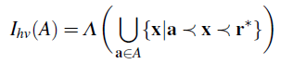 (12)
where Λ is the Lebesgue measure. Higher indicates better convergence and spread performance of the Pareto front approximation.

The inverted generational distance [31] is also a comprehensive index of the convergence and spread. Let A be the Pareto front approximation, R be the real Pareto front. is calculated as follows:
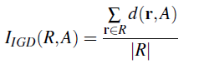 (13)
where is the minimum Euclidean distance between and the points in A. Lower indicates better convergence and spread performance of the Pareto front approximation.
Proposed by Zhang[37], the set coverage metric (C-metric) indicates the percent-age of solutions in one solution set that are dominated by at least one solution in another set. Suppose A, B be two approximations to the PF of a MOP, C(A,B) indicates the percentage of solutions in B that are dominated by at least one solution in A, i.e.,
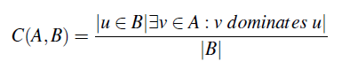 (14)
It’s not necessary that C(A,B)+C(B,A)=1. If C(A,B)=1, then all solutions in B are dominated by at least one solution in A. If C(A,B)=0, then no solution in B is dominated by some solution in A.

4.2 Parameter settings
cMOPSO/D-P and cMOPSO/D-LO are compared to three state-of-the-art algorithms: cMOEA/D [4], D2MOPSO[1] and OMOPSO [27].
Thirty independent runs are performed for each test instance with each algorithm. Five hundred iterations per run are used for all algorithms. For the bi-objective problems, population size of 100 is used for all algorithms. For the three-objective problems, population size of 300 is used for all algorithms. The size of the external crowding distance archive that is used to store the feasible and non-dominated solutions is set to 100 for cMOPSO/D-P, cMOPSO/D-LO, cMOEA/D and D2MOPSO. Originally, OMOPSO uses an ε-crowding archive to store the non-dominated solutions. The parameter ε is used to control the number of solutions stored. In our study, an crowding distance archive of size 100 is used in OMOPSO instead to avoid the adjustment of ε.
The parameter settings for cMOPSO/D-P, cMOPSO/D-LO and cMOEA/D are summarized in Table 2.
For cMOPSO/D-P and cMOPSO/D-LO, N represents the number of weight vectors (100 for two objective and 300 for three objective problems). T represents the neighborhood size and δ represents the probability that solutions are selected from the neighborhood when updating gBest. represents the maximum number of replacements while updating gBest. and are the mutation index for Polynomial-Based Mutation (PBM) and the mutation rate, respectively. is the probability of implementing mutation on a particle. ageThres is the age threshold to invoke the best solution re-initialization procedure and the DE operator (crossover rate: 1.0; mutation rate: 0.5) is used in the procedure. and are the scaling parameters of the penalty function adopted in cMOPSO/D-P.
For cMOEA/D, the parameters N and T have the same meaning with those in cMOPSO/D-P and cMOPSO/D-LO. δ represents the probability that the parents are selected from the neighborhood. represents the maximum number of replacements while updating the population. cMOEA/D uses differential evolution crossover (DE; crossover rate: 1.0; Mutation rate: 0.5) and polynomial mutation (polynomial muta-tion rate: 1/D; the mutation distribution index: 20). The probability of using the local search strategy is set to 0.05.

Table 2. Parameter settings for cMOPSO/D-P, cMOPSO/D-LO and cMOEA/D
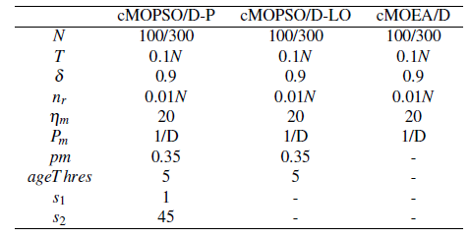
D2MOPSO uses a swarm of size 100/300 (100 for bi-objective problems and 300 for three-objective problems). The leaders’ archive is of the same size with the swarm.
OMOPSO uses the same swarm size with D2MOPSO. The size of the leaders’ archive used for selection is the same with the size of the swarm. Besides, OMOPSO uses turbulence probability of 0.5 and mutation probabilityof1/D.
For OMOPSO and D2MOPSO, the parameters in the flight equation 6 are set as follows: , are assigned random numbers in the range [0,1], , are assigned random numbers in the range [1.5, 2.0] and w is assigned a random number in [0.1,0.5].For cMOPSO/D, decrease linearly from 2.5 to 1.5, increase linearly from 1.5 to 2.5 and w decreases from 0.5 to 0.1, respectively, with the evolution.
While calculating and , the number of feasible non-dominated solutions in the real Pareto front of CF1-CF10 is 21, 999, 999, 1000, 1000, 1000, 1000, 10000, 9408 and 9408, respectively.

4.3 Experimental results and discussion
The performances of different algorithms on the selected test instances (CF1-CF10) are presented in this subsection.

4.3.1 Numeric comparison
Table 3 and Table 5 present the mean and standard deviation of and of the final solutions obtained by each algorithm. Table 4 and Table 6 present the median and interquartile range (IQR) of and of the final solutions obtained by each algorithm. The subscripts in Table 3 and Table 5 denote the standard derivation while the subscripts in Table 4 and Table 6 denote the IQR. Table 7 presents the mean set coverage metrics between cMOPSO/D-P and the other algorithms. Table 8 presents the mean set coverage metrics between cMOPSO/D-LO and another three state-of-the-art algorithms. Better value in each row of the table is marked with darker shadow.
If a solution set obtained by an algorithm in a single run is null(no feasible and non-dominated solutions are found), then the solution set is skipped while calculating the statistic values in the tables. For problem CF1-CF7 and CF9, all the solution sets obtained by each algorithm in different runs are not null. For problem CF8 and CF10, the number of null solution sets obtained by each algorithm over thirty runs is shown in Table 10.
From Table3 – Table 8 we could find that cMOPSO/D and cMOEA/D generally perform better than OMOPSO and D2MOPSO but a few exceptions. In terms of the mean value of , OMOPSO performs better than cMOPSO/D for CF2. In terms of the set coverage metric, D2MOPSO performs better than cMOPSO/D-P for problem CF3 and CF8. And D2MOPSOperforms better than cMOPSO/D-LO for CF3 and CF9. From Table 3 and 4 we could find that in terms of , cMOEA/D performs better than cMOPSO/D for CF2, CF3 and CF4. cMOPSO/D outperforms cMOEA/D for CF1,CF8,CF9 and CF10.From Table5 and 6 we could find that in terms of , cMOEA/D performs better than cMOPSO/D for CF2, CF3, CF4. CF5, CF7 and CF9. cMOPSO/D performs better than cMOEA/D for the other problems. From Table 7 we could find that in terms of the set coverage metric, cMOEA/D performs better than cMOPSO/D-P for CF2-CF7. From Table 8 we could find that in terms of the set coverage metric, cMOEA/D performs better than cMOPSO/D-LO for CF2-CF6.
Besides, the Wilcoxon rank sum test is implemented on the values over 30 runs to determine whether the difference between the medians is statistically signiﬁant. Low p-values support a conclusion that the medians obtained by two algorithms are statistically significant. Table 9 presents the p-values produced by Wilcoxon rank sum test implemented on the values between cMOPSO/D and three state-of-the-art algorithms. The significance level is often set at 0.05. Thus from Table 9(a) and Table4 we could conclude that cMOEA/D is significantly better than cMOPSO/D for CF2-4 and CF7. cMOPSO/D-P performs significantly better than cMOEA/D for CF1, 6, 9and 10. cMOPSO/D-LO performs significantly better than cMOEA/D for CF1, 6,8 and 10. We could also conclude that cMOPSO/D performs significantly better than OMOPSO for all test instances. cMOPSO/D-P outperforms D2MOPSO significantly except CF1 ,3 and 7. cMOPSO/D-LO outperforms D2MOPSO significantly except CF3 and 7.
Table 3. Mean and standard deviation
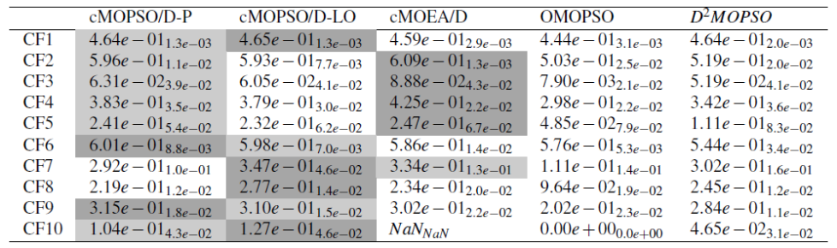

Table 4. Median and IQR
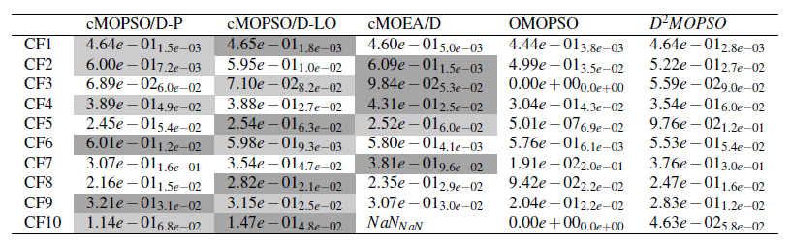

Table 5. Mean and standard deviation
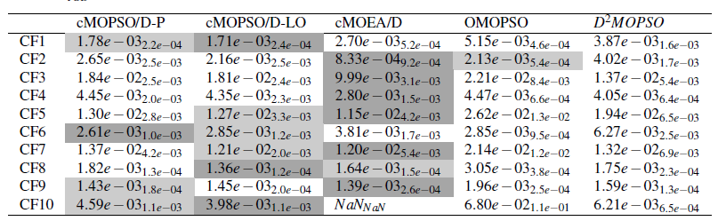

Table 6. Median and IQR
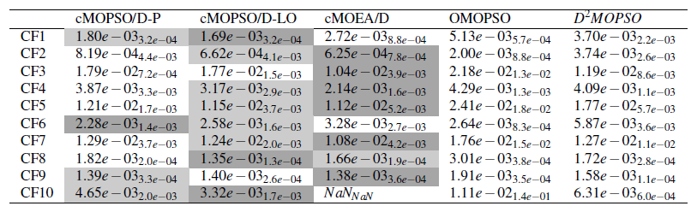

Table 7. Mean set coverage metrics between cMOPSO/D-P and the other algorithms
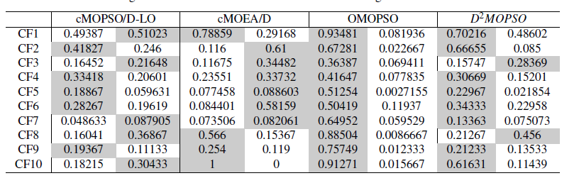

Table 8. Mean set coverage metrics between cMOPSO/D-LO and another three state-of-the-art algorithms
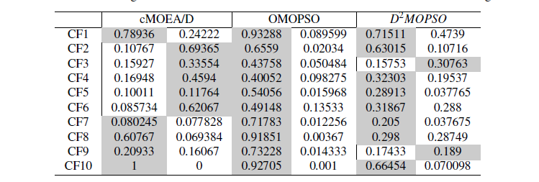
Table 9. The p-value of between cMOPSO/D and three state-of-the-art algorithms
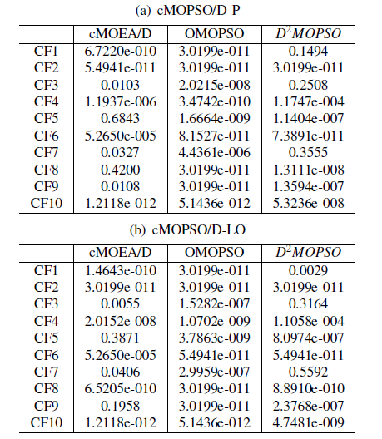

Table 10. Number of null solution sets obtained by each algorithm on CF8 and CF10 over 30 runs
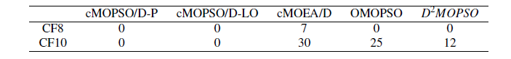

4.3.2 Visual comparison
To demonstrate the performances of different algorithms visually, the Pareto fronts obtained with the biggest hypervolume values by cMOPSO/D-P, cMOPSO/D-LO, cMOEA/D, OMOPSO and D2MOPSO are represented in Figure 2, Figure 3, Figure 4, Figure 5 and Figure 6, respectively. The real Pareto front for each problem is plotted in each figure using red dots and the approximated Pareto front is plotted using blue circles. Notice that in Figure 4, the solution set obtained for CF10 is null, thus the true front and the approximated front are not presented. From these figures we could see that problem CF3, CF5, CF7 and CF10 are relatively hard. For CF3, CF5 and CF7, cMOEA/D performs generally better than the other algorithms with respect to the spread of the approximated front.
Besides, the convergence property of each algorithm on the test instances are studied. Figure 7 shows the evolution of the average values of the current solution set obtained by each algorithm for the ten test instances. Notice that for CF8 and CF10, the runs with null final solution set are skipped while calculating the average values. Figure 7 shows that cMOPSO/D-P, cMOPSO/D-LO and D2MOPSO converge faster than cMOEA/D and OMOPSO in most cases. cMOPSO/D has similar convergence rate as D2MOPSO unless for CF8, in which case cMOPSO/D-P converges slower than the other algorithms except OMOPSO.

4.3.3 Computational complexity analysis
For fair comparison, an external archive is used in our study for each algorithm to store the feasible and non-dominated solutions. Thus for an algorithm of population/swarm size N and external archive size K(K≤ N), its external archive updating procedure has a computational complexity of O(KN).
cMOEA/D uses a neighborhood of size T (with a probability of δ)and at most (< T) solutions are replaced in the neighborhood. Therefore, for a population of size N, the computational complexity of cMOEA/D is O() (the worst-case scenario is: each individual of the population has to be compared with all the other individuals). Considering the external archive update procedure, the overall computational complexity of cMOEA/D is O(+KN) ≈ O(). OMOPSO uses the leaders’ archive of size N and its updating procedure requires a computational complexity of O(). In addition, it uses and external crowing archive of size K(K≤ N) in our study to store the feasible and non-dominated solutions, thus the overall computation-al complexity of OMOPSO is O(+KN)≈O(). D2MOPSO uses the leaders’ archive of size N(which is equal to the swarm size) in our study. The leaders’ archive is updated on each iteration and it is used to select the global leader for each particle, thus the computational complexity would be O(). When an external archive is used, the overall computational complexity of D2MOPSO is O(+ KN) ≈ O().
As cMOEA/D, cMOPSO/D uses a neighborhood of size T (with a probability of δ) and a maximum replacements of . Besides, the global best leader for each particle in the swarm is selected according to a gBest selection procedure, thus the computational complexity of cMOPSO/D is O(+) ≈ O(). Taking the external archive update procedure and gBest re-initialization procedure into consideration, the overall computational complexity of cMOPSO/D would be O(+ KN+ N) ≈ O().
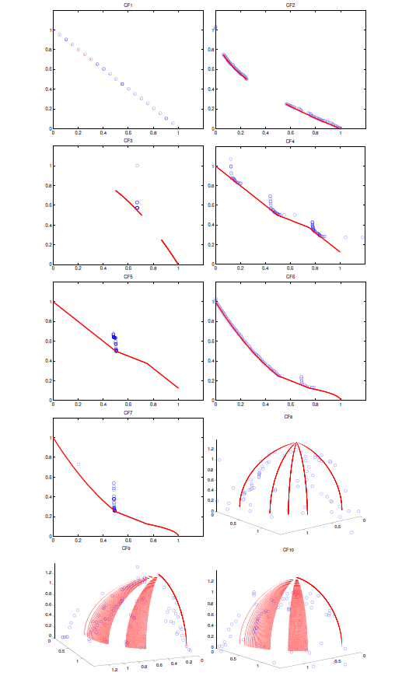
Fig. 2. Feasible and non-dominated solutions with the biggest values in 30 runs of cMOPSO/D-P
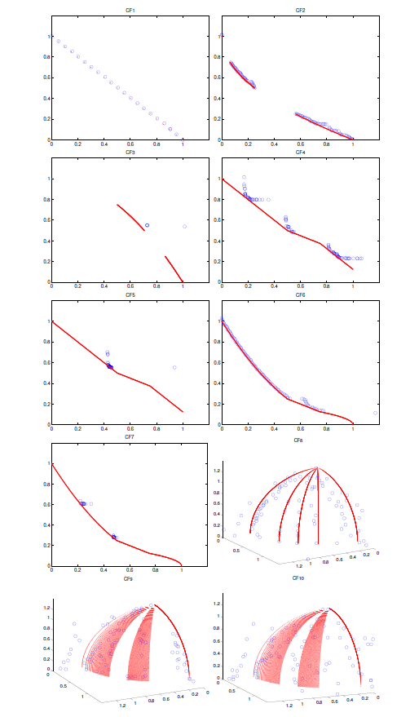
Fig. 3. Feasible and non-dominated solutions with the biggest values in 30 runs of cMOPSO/D-LO

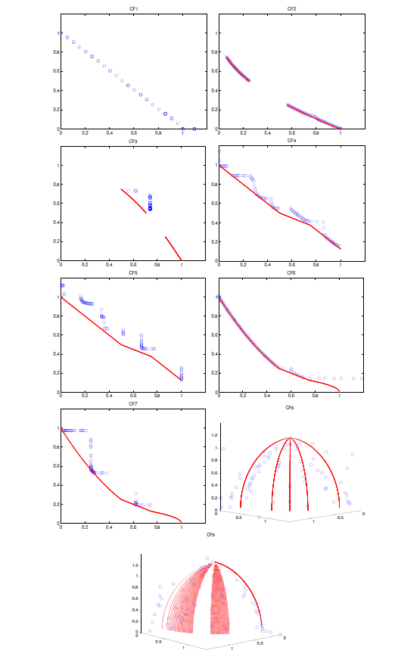
Fig. 4. Feasible and non-dominated solutions with the biggest values in 30 runs of cMOEA/D

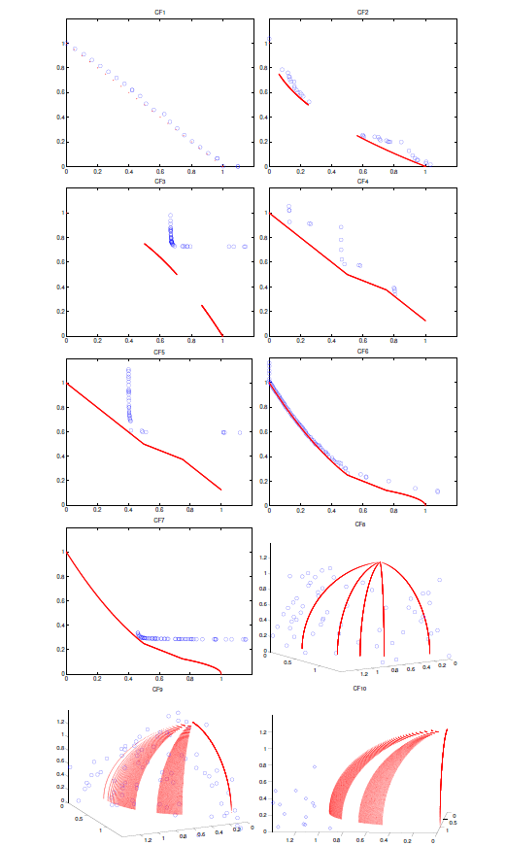
Fig. 5. Feasible and non-dominated solutions with the biggest values in 30 runs of OMOPSO

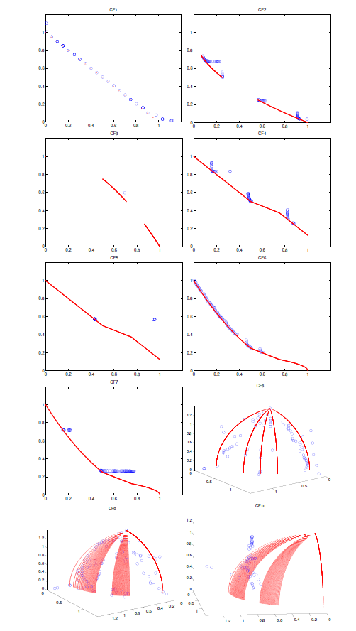
Fig. 6. Feasible and non-dominated solutions with the biggest values in 30 runs of D2MOPSO

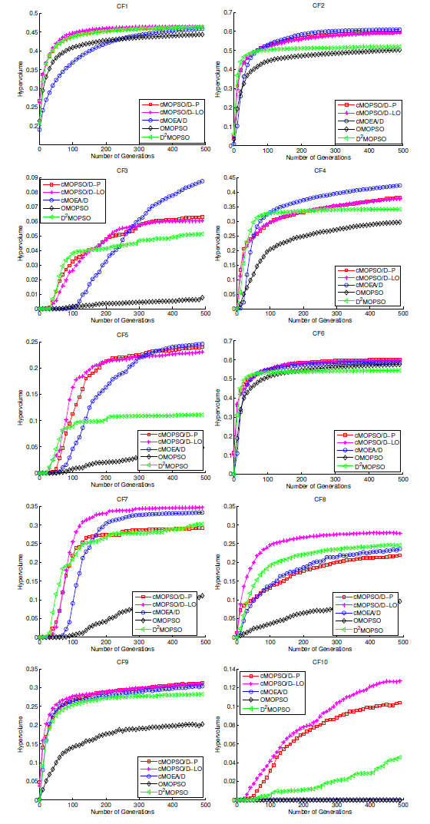
Fig. 7. Evolution of the mean of values

4.3.4 Discussion
From Figure 2-Figure6 we could see that for some problems such as CF3, CF5 and CF7, some parts of the true Pareto front seem very hard be obtained. The approximated Pareto front obtained by an algorithm is often composed of several clusters that are separated by some gaps. Similar results could be seen in Jan’s study [14]. Since a subproblem in MOEA/D is solved based on the information provided by its neighborhood subproblems, the search in the neighborhood may be influenced by each other. Thus we think that how the information should be used in constrained MOEA/D needs to be further studied.
From Figure 2-Figure 6, we could also see that for some problems, PSO-based algorithms tend to be trapped in local optima. This may be caused by the high-convergence-rate nature of PSO. Thus some mechanisms to improve the diversity of the swarm are necessary. The advantage of cMOPSO/D over D2MOPSO and OMOPSO may be caused by several reasons. First, the constraint handling techniques adopted by cMOPSO/D are more effective. Second, the update and selection mechanisms of pBest and gBest are advantageous. Third, the pBest and gBest reinitialization mechanisms help to improve the diversity of the swarm.
From the experimental results we could see that cMOEA/D outperforms cMOPSO/D in several test instances. On the one hand, this could be caused by the nature of PSO. The evolutionary operators adopted by cMOEA/D may help to enhance its global search ability. On the other hand, the local search operator adopted by cMOEA/D may result in this advantage. The local search operator helps to enhance the search ability of cMOEA/D further.5.Conclusions and future work
cMOPSO/D is proposed in this paper as a new framework of decomposition based MOPSO for constraint handling. Combining cMOPSO/D with two typical constraint handling techniques, we get two versions of cMOPSO/D: cMOPSO/D using penalty function (cMOPSO/D-P) and cMOPSO/D using lexicographic ordering (cMOPSO/D-LO). The constraint violation thresholds used in cMOPSO/D-P and cMOPSO/D-LO are calculated based on a mechanism that takes both the swarm and the best population (pBest or gBest) into consideration. The global best leader selection procedure adopted in cMOPSO/D introduces a high selection pressure while the re-initialization procedure of the best solutions helps to improve the swarm diversity.
The performances of cMOPSO/D-P and cMOPSO/D-LO are tested on ten CMOPs that are widely used in recent studies. Besides, cMOPSO/D-P and cMOPSO/D-LO are compared with three state-of-the-art algorithms (cMOEA/D, OMOPSO and D2MOPSO). Three performance metrics including , and set coverage metric, are used to compare the algorithms quantitatively. Experimental results show that the proposed algorithms outperform existing MOPSO algorithms significantly in most cases. Compared with cMOEA/D, cMOPSO/D has similar performance in general while has an advantage in convergence speed. The advantage of cMOEA/D in some test instances may be attributed to the local search operator adopted by cMOEA/D. In general, cMOPSO/D proves to be very promising.
Though the framework proposed has been proved effective on some instances, some important issues remain to be further studied in order to improve its performance on different test instances. In the future, firstly, we will try to design more effective constraint handling techniques that could take the features of MOPSO/D into consideration. Secondly, the way in which the best population is stored and used in MOPSO/D is a core issue. Thus we plan to explore different strategies to store the best solutions and different leader selection mechanisms in MOPSO/D for constraint handling. Thirdly, we will try to introduce some other successful constraint handling techniques such as repair methods or local search strategies [25,16,26,24,35] into the proposed cMOPSO/D framework.

References
[1] Al Moubayed, N., Petrovski, A., McCall, J. D2mopso: Mopso based on decomposition and dominance with archiving using crowding distance in objective and solution spaces [J]. Evol. Comput, 2014, 22(1):47:77.
[2] Ali, M., Golalikhani, M., Zhuang, J. A computational study on different penalty approaches for solving constrained global optimization problems with the electromagnetism-like method [J]. Optimization, 2012, 63(3):403:419.
[3] Ali, M.M., Zhu,W.X. A penalty function-based differential evolution algorithm for constrained global optimization [J]. Computational Optimization and Applications, 2013, 54(3):707:739.
[4] Asafuddoula,M.,Ray,T.,Sarker,R.,Alam,K. An adaptive constraint handling approach embedded MOEA/d [C]. In: 2012 IEEE Congress on Evolutionary Computation (CEC), 2012, 1-8.
[5] Chenggang, C., Xiaofei,Y.,Tingyu, G. A self-adaptive interior penalty based differential evolution algorithm for constrained optimization [C]. In:Y.Tan,Y. Shi, C.A.C. Coello (eds.) Advances in Swarm Intelligence, no. 8795 in Lecture Notes in Computer Science, 2014, 309-318.
[6] Coello, C., Pulido, G., Lechuga, M. Handling multiple objectives with particle swarm optimization [J]. IEEE Transactions on Evolutionary Computation, 2004, 8(3):256:279.
[7] Coello Coello, C.A. Theoretical and numerical constraint-handling techniques used with evolutionary algorithms: a survey of the state of the art [J]. Computer Methods in Applied Mechanics and Engineering, 2002, 191(11–12):1245:1287.
[8] Dadios, E.P., Ashraf, J. Genetic algorithm with adaptive and dynamic penalty functions for the selection of cleaner production measures: a constrained optimization problem [J]. Clean Technologies and Environmental Policy, 2006, 8(2):85:95.
[9] Deb, K. An efficient constraint handling method for genetic algorithms [J]. Computer Methods in Applied Mechanics and Engineering, 2000, 186(2–4):311:338.
[10] Deb,K., Pratap,A.,Agarwal,S.,Meyarivan,T. A fast and elitist multiobjective genetic algorithm: NSGA-II [J].Evolutionary Computation, IEEE Transactions on, 2002, 6(2):182:197.
[11] Durillo, J.J., Garc´ı-Nieto, J., Nebro, A.J., Coello, C.A.C., Luna,F., Alba, E. Multi-objective particle swarm optimizers: An experimental comparison [C]. In: Evolutionary Multi-Criterion Optimization, 2009, 495-509.
[12] Durillo, J.J., Nebro, A.J. jMetal: A java framework for multi-objective optimization [J]. Advances in Engineering Software, 2011, 42(10):760:771.
[13] Efr´en Mezura-Montes, C.A.C.C. Constraint-handling in nature-inspired numerical optimization: Past, present and future [J]. Swarm and Evolutionary Computation1, 2011, 1:173-194.
[14] Jan, M., Zhang, Q. MOEA/d for constrained multiobjective optimization: Some preliminary experimental results [C]. In: 2010 UK Workshop on Computational Intelligence (UKCI), 2010, 1-6.
[15] Kennedy,J., Eberhart,R. Particle swarm optimization [C]. In:, IEEE International Conference on Neural Networks, 1995, Proceedings, 4:1942-1948.
[16] Leguizamon, G., Coello Coello, C.A. Boundary search for constrained numerical optimization problems with an algorithm inspired by the ant colony metaphor [J]. IEEE Transactions on Evolutionary Computation, 2009, 13(2):350:368.
[17] Lin, C.Y.,Wu,W.H. Self-organizing adaptive penalty strategy in constrained genetic search [J]. Structural and Multidisciplinary Optimization, 2004, 26(6):417:428.
[18] Miettinen, K.,M¨akel¨a, M.M.,Toivanen, J. Numerical comparison of some penalty-based constraint handling techniques in genetic algorithms [J]. Journal of Global Optimization, 2003, 27(4):427:446.
[19] Padhye, N. Comparison of archiving methods in multi-objective particle swarm optimization (MOPSO): empirical study [C]. In: Proceedings of the 11th Annual conference on Genetic and evolutionary computation, 2009, 1755:1756.
[20] Parsopoulos, K.E., Vrahatis, M.N. Multi-objective particles swarm optimization approaches [M]. In: Multi-objective optimization in computational intelligence: Theory and practice, 2008, 20–42.
[21] Peng,W., Zhang, Q. A decomposition-based multi-objective particle swarm optimization algorithm for continuous optimization problems [C]. In: IEEE International Conference on Granular Computing, 2008, 534–537.
[22] Reyes-Sierra, M., Coello, C.C. Multi-objective particle swarm optimizers: A survey of the state-of-the-art [J]. International journal of computational intelligence research, 2006, 2(3):287:308.
[23] Runarsson,T.,Yao, X. Stochastic ranking for constrained evolutionary optimization [J]. IEEE Transactions on Evolutionary Computation, 2000, 4(3):284:294.
[24] Saha, A., Ray, T. A repair mechanism for active inequality constraint handling [C]. In: 2012 IEEE Congress on Evolutionary Computation (CEC), 2012, 1–8.
[25] Salcedo-Sanz,S. A survey of repair methods used as constraint handling techniques in evolutionary algorithms [J]. Computer Science Review, 2009, 3(3):175:192.
[26] Sardar,S., Maity,S., Das,S., Suganthan,P. Constrained real parameter optimization with a gradient repair based differential evolution algorithm [C]. In: 2011 IEEE Symposium on Differential Evolution (SDE), 2011, 1–8.
[27] Sierra, M.R., Coello, C.A.C. Improving PSO-based multi-objective optimization using crowding, mutation and ε-dominance [M]. In: C.A.C. Coello, A.H. Aguirre, E. Zitzler (eds.) Evolutionary Multi-Criterion Optimization, no. 3410 in Lecture Notes in Computer Science, 2005, 505–519.
[28] Smith, A., Smith, a.A.E., Coit, D.W., Baeck,T.,Fogel, D., Michalewicz, Z. Penalty Functions [M]. Oxford University Press and Institute of Physics Publishing, 1997.
[29] Takahama,T.,Sakai,S. Constrained optimization by applying the alpha; constrained method to the nonlinear simplex method with mutations [J]. IEEE Transactions on Evolutionary Computation, 2005, 9(5):437:451.
[30] Takahama,T., Sakai, S. Constrained optimization by ε constrained particle swarm optimizer with ε-level control [M]. In: D.A. Abraham,P.D.Y. Dote,P.D.T. Furuhashi, D.P.M.K¨oppen,P.A. Ohuchi, D.Y. Ohsawa (eds.) Soft Computing as Transdisciplinary Science and Technology, no. 29 in Advances in Soft Computing, 2005, 1019–1029.
[31] Veldhuizen, D.A.V., Lamont, G.B. Multiobjective Evolutionary Algorithm Research: A History and Analysis[M]. 1998.
[32] Woldesenbet,Y.,Yen,G.,Tessema,B. Constraint handling in multiobjective evolutionary optimization [J]. IEEE Transactions on Evolutionary Computation, 2009, 13(3):514:525.
[33] Yeniay, O.: Penalty function methods for constrained optimization with genetic algorithms [J]. Mathematical and Computational Applications, 2005, 10(1):45–56.
[34] Zapotecas Mart´ıez, S., Coello Coello, C.A. A multi-objective particle swarm optimizer based on decomposition [C]. In: Proceedings of the 13th Annual Conference on Genetic and Evolutionary Computation, GECCO’11, 2011, 69–76.
[35] Zapotecas Mart´ıez, S., Coello Coello, C.A. A direct local search mechanism for decomposition-based multi-objective evolutionary algorithms [C]. In: 2012 IEEE Congress on Evolutionary Computation (CEC), 2012, 1–8.
[36] Zapotecas Mart´ıez,S., Coello Coello, C.A. A multi-objective evolutionary algorithm based on decomposition for constrained multi-objective optimization [C]. In: 2014 IEEE Congress on Evolutionary Computation (CEC), 2014, 429–436.
[37] Zhang,Q., Li,H. MOEA/d: A multiobjective evolutionary algorithm based on decomposition [J]. IEEE Transactions on Evolutionary Computation, 2007,11(6):712:731.
[38] Zhang, Q., Zhou, A., Zhao, S., Suganthan,P.N., Liu,W.,Tiwari, S. Multiobjective optimization test instances for the CEC 2009 special session and competition [R]. University of Essex, Colchester, UK and NanyangTechnological University, Singapore, Special Session on Performance Assessment of Multi-Objective Optimization Algorithms, Technical Report, 2008.
[39] Zitzler, E., Thiele, L. Multiobjective optimization using evolutionary algorithms — a comparative case study [M]. In: A.E. Eiben,T.B¨ack, M. Schoenauer, H.P. Schwefel (eds.)Parallel Problem Solving from Nature — PPSN V, no. 1498 in Lecture Notes in Computer Science, 1998, 292–301.
[40] Zitzler, E., Thiele, L. Multiobjective evolutionary algorithms: a comparative case study and the strength pareto approach [J]. IEEE Transactions on Evolutionary Computation, 2009, 3(4):257:271.

具有多物理特性的X射线脉冲星信号仿真
沈利荣 李小平 方海燕 孙海峰 裴辰星 薛梦凡
(西安电子科技大学 空间科学与技术学院，陕西 西安 710071)

摘要：针对目前X射线脉冲星实测数据量少且不连续的问题，本文以罗西卫星X射线脉冲星实测数据物理特性为先验信息，采用快速迭代法在10us时间转换模型下，仿真产生了航天器处具有周期特性、能谱特性、背景噪声特性及具有各种延迟效应的X射线脉冲星信号，设计和实现了具有多物理特性的X射线脉冲星信号仿真软件。比较相同条件下实测和仿真数据可得：仿真噪声和实际噪声具有相同的分布；实测与仿真脉冲星数据周期变化趋势吻合，误差仅为0.93%；不同能级仿真和实测数据累积轮廓的皮尔逊相关系数达0.99以上；10us时间转换模型下，仿真数据时间转换误差仅为10⁻⁷s，仿真数据和实测数据误差也仅为10⁻⁷s，满足时间转换精度要求。所以，本文方法可实现具有多物理特性的X射线脉冲星信号的连续获取。
关键词：X射线脉冲星，信号仿真，周期特性，能谱特性，背景噪声特性，时间转换
中图分类号：P128.4文献标识码：A 文章编号：

The simulation of X-ray pulsar signals with multi-physical properties

Lirong Shen,Xiaoping Li, HaiyanFang,Haifeng Sun, ChenxingPei,Mengfan Xue
(School of Aerospace Science and Technology, XidianUniv., Xi’an 710071, China; )

Abstract: In view of thefewand discontinuous X-ray pulsar data,based on the physicalproperties of the X-ray pulsar real data from the Rossi X-ray Timing Explorer (RXTE) spacecraft, this paperadopted the fast iterative method and the 10 us time transformation model, simulated the X-ray pulsar signals which have the period property, spectral property, the background noise property and with a variety of delay effects, designed and implementeda simulation software which can simulate the X-ray pulsar signals with multi-physical properties. The results of comparing the real data and simulation data in the same situation show thatthe simulation noiseand the actual noise have the same distribution, the period stability of the simulated X-ray pulsar data agrees with the real data, the error is only 0.93%, in differentenergy levels, thesimulated data’s integrated profile and the real data’s standard profile is highlycorrelated with Pearsoncorrelationcoefficientof 0.99, under the 10 us time transformation model, the time conversion accuracy of the simulation data can reach 10⁻⁷ s, the error between the simulation and the real data is just only 10⁻⁷s, which meet the time transformation accuracy. Therefore, the proposedmethod can produce the continuous pulsar signal with many physical properties.
Key Words: X-ray pulsar, signal simulation, periodproperty, spectral property, the background noise property,time transformation
- 引言
脉冲星是一种高速旋转的中子星，它可在射电、X射线等波段周期性的向外辐射脉冲星信号，其中毫秒脉冲星的周期稳定性可与原子钟相媲美，被誉为宇宙灯塔和天然的导航信标[1]。所以，脉冲星可用来为近地、深空探测器提供位置、速度、姿态、时间等导航信息，对未来深空探测具有深远意义。因为X射线脉冲星具有良好的空间位置分布，同时，航天器上面积较小的X射线探测器可实现X射线脉冲星信号的接收，所以基于X射线脉冲星的自主导航技术成为了近年来国内外学者的研究热点^{[2-4]}。
近年来欧洲的XMM-牛顿卫星，美国的RXTE卫星，Chandra X射线天文台等为X射线脉冲星物理特性与基于X射线脉冲星导航的研究提供了重要观测数据^{[4,5]}。其中RXTE卫星在轨16年，对外公布了大量X射线脉冲星数据。我国脉冲星观测起步较晚，1984年，中科院高能物理研究所和紫金山天文台利用高空科学气球搭载望远镜成功观测了Crab脉冲星等X射线脉冲辐射,1997年风云二号A(FY-2)搭载的X射线望远镜对太阳X射线流量进行了监测。最近由中科院高能物理所和清华大学天体物理中心共同设计研制的硬X射线调制望远镜（Hard X-ray Modulation Telescope，HXMT)也将发射升空，用于实现空间硬X射线高分辨率巡天及致密天体、黑洞强引力场中动力学和高能辐射过程的研究^{[6]}。所以，目前我国还没有自己的脉冲星观测数据，而国外公布的X射线脉冲星数据量少、不连续、精度低。为解决上述问题，国内学者研究了脉冲星数据的半物理模拟法和数值模拟法^{[7-10]}。其中半物理模拟法受物理器件精度的限制，仿真精度有待提高且存在不灵活的缺点。数值模拟法虽然高效、灵活，但不能反应脉冲星信号的物理特性。
针对我国脉冲星导航研究中急需时间连续、有效的导航信号需求，本文基于罗西卫星实测脉冲星数据物理特性，研究了一种航天器处具有周期特性、能谱特性、背景噪声特性及具有各种时空效应的X射线脉冲星信号仿真方法，设计并开发了航天器处具有多物理特性的脉冲星信号仿真软件。该软件可实现不同噪声流量下、不同脉冲星信号能级下、具有周期特性、轮廓特性和大尺度时空效应的X射线脉冲星信号仿真。
- X射线脉冲星信号模型
X射线脉冲星信号可用X射线脉冲星辐射的X射线光子到达时间表示，其可被航天器上的X射线探测器接收到^{[7,8,13]}。设(t₀, t_{f})是观测时间间隔，总观测时间为T_{obs},其中T_{obs}=t_{f} -t₀,是第i个光子到达时间，则T_{obs}内所有光子到达时间可表示为{t₁,t₂…t_{N}}，满足t₀≤t₁<…<t_{N} ≤ t_{f}。(t₀, t_{f}) 内观测的光子到达时间个数为N，它是一个随机变量。
当t₀=0时，N₀=0，则有，其中。该光子到达时间序列的个数是一个(0, t)范围内的随机点过程，可建模为非齐次泊松过程，其时变速率函数为λ(t) ≥0，代表所有源和背景的累积光子到达速率^{[3]}。那么在 (0, t)内接收到m个光子的概率为^{[3]}
(1)
其中m是整数。的均值和方差可表示为==。其中，λ_{s}为源光子速率，λ_{b}为背景光子速率。h()是周期性的轮廓函数,∈(0,1),h()=h()，满足, n为整数。是相位函数，可被表示为
(2)
其中，t₀为射电脉冲星相位模型参考起始时间，是t₀时刻太阳系质心（Solar System Barycenter，SSB）处的脉冲相位，，，分别为脉冲星自转频率，自转频率一阶导数，二阶导数。
将相位模型带入到脉冲星信号的累积速率函数中，可以建立SSB处具有背景噪声特性，轮廓特性，周期特性的脉冲星信号模型，
(3)
- 航天器处具有多物理特性的X射线脉冲星信号仿真方法
  - 总体仿真方案
为仿真产生航天器处具有多物理特性的X射线脉冲星信号，在已知准确的脉冲星星历、太阳系星历、航天器轨道文件以及X射线宇宙背景噪声特性等信息下，本文设计如下仿真步骤：
1）根据脉冲星相位预测模型，计算仿真起始时刻t在SSB处的相位；
2）确定仿真总时间T_{obs}，由实测数据处理获取SSB处脉冲星信号不同能级标准轮廓；
3）以该标准轮廓为先验信息仿真SSB处起始时刻为t、服从非齐次泊松过程的光子到达时间{t_{i}}；
4）对上述光子到达时间进行太阳质心力学时（Barycentric Dynamical Time, TDB）到航天器固有时的转换，得到航天器处光子到达时间；
5）根据宇宙背景噪声模型生成噪声光子序列，并将噪声光子序列加入到仿真的脉冲星光子序列中，得到航天器处包含噪声特性、脉冲星周期特性，能级轮廓特性及具有各种时空效应的脉冲星信号。
  - 具有噪声、周期、能级和时间转换特性的脉冲星光子序列仿真算法
由反函数法生成非齐次泊松随机序列^{[3]}的过程可知，当第个光子到达时刻为时，则与下一个光子到达的时间间隔为
(4)
其中U是[0，1]之间的均匀随机变量，因为U和1-U具有相同的分布，所以式（4）可以重新表示为。令表示指数分布随机变量，当时，则可表示为
(5)
上述光子序列产生方法不能模拟脉冲星信号的周期缓变特性。模拟的脉冲星信号不具有真实性和可靠性。如果利用该模拟信号进行脉冲星导航算法研究将会引入较大的误差。
因为脉冲星光子瞬时Poisson速率是脉冲星信号相位的函数，相位模型反映了脉冲星信号的周期特性，所以本文采用脉冲星信号的相位模型、不同能级轮廓信息，仿真产生具有周期和能级特性的脉冲星信号。
本文将式(5)中的光子时刻用光子相位替代，可得到下一个光子的相位
(6)
脉冲星光子相位和脉冲星光子到达时间一一对应，在已知相位时，可反推求解该相位所对应的SSB处脉冲星光子到达时刻
(7)
式(6)的求解需要求的反函数，脉冲星辐射强度是一个不规则的波形，难以用解析式表示。本文将离散化，以离散点作为自变量，以脉冲星信号相位作为，通过插值法求解第个光子的相位。由该相位和脉冲星不同能级轮廓信息即可产生SSB处具有能级和周期特性的光子序列。该光子到达时间序列是SSB处的TDB时，而航天器处接收的光子到达时间是航天器固有时，要模拟航天器处接收到的X射线脉冲星信号，本文对模拟的SSB处的光子到达时间序列进行光行时转换和时间尺度转换，使其转换为航天器处的固有时。
本文采用10us光行时转换模型如下所示
(8)
该式可计算光子从SSB到航天器传播过程所需的时间。其中，是光子在SSB处的TDB时，是光子到达航天器处的TDB时，为航天器相对于SSB的位置矢量，满足，为脉冲星辐射单位矢量，µ_{s}为太阳引力常数，为航天器相对于太阳中心的位置矢量。、和的计算需要已知光子在航天器处的TDB时和太阳系星历的相关参数，因此，不能解析计算，本文用迭代法求解，步骤如下所示：
步骤1.令迭代次数k=0，，，停止迭代条件ε=10⁻¹²（s）；
步骤2.已知SSB处光子到达时间，设，得航天器处有误差的初始TDB时，用表示；
步骤3.在已知和的情况下，计算、和，带入式（8），计算其右边的值,得到；
步骤4.计算航天器处TDB时的误差，若，停止迭代，否则，令k=k+1，转至步骤2，继续迭代。
此时，模拟的航天器处光子到达时间是TDB时，必须转换到TT时，本文采用如下时间尺度转换公式，
(9)
其中是光子到达航天器处的地球力学时（Terrestrial Time，TT），是光子到达航天器处时TDB时,是航天器相对于地心的位置矢量，是地心相对于SSB的速度矢量，P包括所有的周期改正项。计算需要已知光子到达航天器处的固有时和航天器轨道文件，而航天器处TT时正是需要求解的，因此本文也采用迭代法求解航天器出的TT时。
最后，为仿真宇宙背景噪声，本文采用齐次泊松过程。以宇宙背景噪声实测数据流量分析结果作为先验信息。设poison强度为，t₀为第0个噪声光子，仿真总时间为T，可通过如下步骤得到噪声光子序列：
步骤1.设初值k=0，初始光子到达时间t₀等于光子到达时间间隔，即，U是[0，1]之间的均匀随机变量；
步骤2.若，停止光子序列的产生；否则，转至步骤3，k=k+1；
步骤3. ,然后转步骤2，直至结束。
最后，得到的时间序列{t₀, t₁, …, t_{k}}即可表示宇宙背景噪声的到达时间。
所以，本文所提方法产生的带噪声脉冲星光子到达时间序列包括了脉冲星的周期特性、能级和轮廓特性及大尺度时空效应，可高精度的模拟航天器处接收到的X射线脉冲星信号。
3.3具有多物理特性的X射线脉冲星信号仿真软件设计及实现
根据脉冲星信号仿真软件需求分析，本文设计了仿真软件架构，如图1所示。
图1航天器处具有多物理特性脉冲星信号仿真软件架构
该架构分为数据访问层、业务逻辑层和显示交互层。数据访问层用于访问脉冲星基本参数（位置、周期等）、太阳系星历文件JPL DE200和JPL DE405、航天器轨道文件等，为仿真算法提供入口参数。业务逻辑层负责数据库交互、数据访问和数据格式解析、光子序列生成、光子序列分析等，仿真算法主要集成在该模块。显示交互层可实现数据库管理、仿真参数设置、仿真任务管理、分析结果输出等功能。其中光子序列生成模块直接调用底层数据库进行光子序列仿真计算，由脉冲星信号特征、SSB处光子到达时间模型及时间转换模型组成，三者顺序执行，最终生成航天器处具有多对物理特性的光子到达时间序列。光子序列的分析功能完成脉冲星周期搜索、光子流量统计、不同能级轮廓特性分析，噪声序列的产生及分布特性分析以及时间转换模型的分析与验证等。
- 实验及分析
为验证本仿真方案的有效性，本文以Crab（PSR B0531+21）脉冲星为例，用本文算法进行航天器处具有多物理特性脉冲星光子序列的仿真和有效性验证。
（1）大尺度空间下的时间转换模型验证。首先，本文选取Crab脉冲星90802-02-02-00数据包的一段实测数据；然后，利用本仿真算法产生SSB处相同参数下的光子到达时间序列，以10us时间转换模型将仿真产生的光子序列转换到航天器处的固有时。最后，比较相同时间段下，实测数据和仿真产生数据之间误差，结果如图2所示。
从图2可以看出，本软件仿真产生的光子到达时间序列的时间转换精度可达10⁻⁷s。相同时间段下，仿真数据与的实测数据之间的误差也仅为10⁻⁷s，满足10us精度要求，说明了本文所提出的脉冲星信号仿真方法可以模拟大尺度空间下的传播效应，在时间转换模型确定情况下可高精度模拟航天器处脉冲星信号。

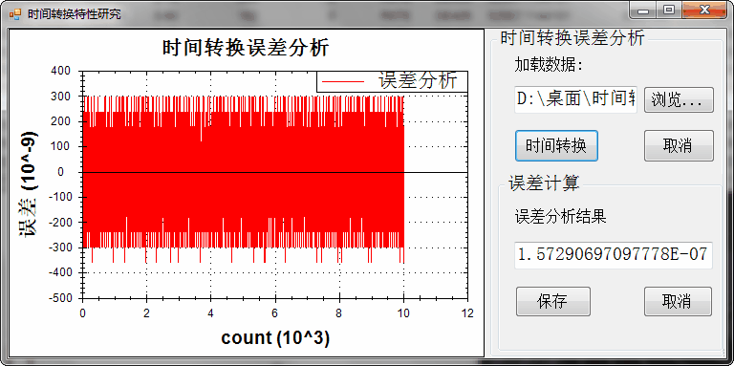
图2 时间转换误差
（2）脉冲星自转周期特征验证。首先，本文选取了RXTE卫星观测的Crab脉冲星12年里的12个时间段的实测数据，获取实测数据周期。然后，利用本文脉冲星信号仿真方法，以相同的参数仿真产生这12段脉冲星数据，其中每个时间段仿真时长1200s，脉冲星平均流量为1.54ph/cm²s，探测器面积为1000cm²。然后对该12段数据进行周期搜索结果如表1所示。
表1Crab脉冲星仿真和实测数据周期比较
仿真起始时间（MJD） | 仿真数据周期 | 实测数据周期
50856.3362521296 | 29.8685 | 29.8683743565635
51268.5856965741 | 29.8559 | 29.8555751637558
51955.5051410185 | 29.8329 | 29.8328580713818
52232.2522359259 | 29.8240 | 29.8240004330897
52472.8251525926 | 29.8161 | 29.8161489981543
52739.1690299074 | 29.8074 | 29.8073012893555
53077.1678493518 | 29.7963 | 29.7963662321416
53502.9897706482 | 29.7826 | 29.7827532268945
53975.2488794444 | 29.7685 | 29.7681916750918
54831.7356965741 | 29.7405 | 29.7405977242989
55269.2665183333 | 29.7253 | 29.7250279952242
55786.7455808333 | 29.7090 | 29.7094147781873
由表1可知仿真数据与实测数据周期变化趋势一致，随着观测时间增长，脉冲星旋转频率变慢。为了进一步分析仿真数据和实测数据周期变化的差异，本文对12组实测数据和仿真数据的周期进行了拟合，其变化趋势可用一次多项式分布的模型表示。拟合结果如图3所示，其中仿真数据周期变化的趋势可拟合为
，实测数据周期可拟合为。周期变化趋势（曲线斜率）相对误差仅为0.93%，说明本方法产生的光子序列具有脉冲星的周期特性，验证了本仿真方法的有效性。
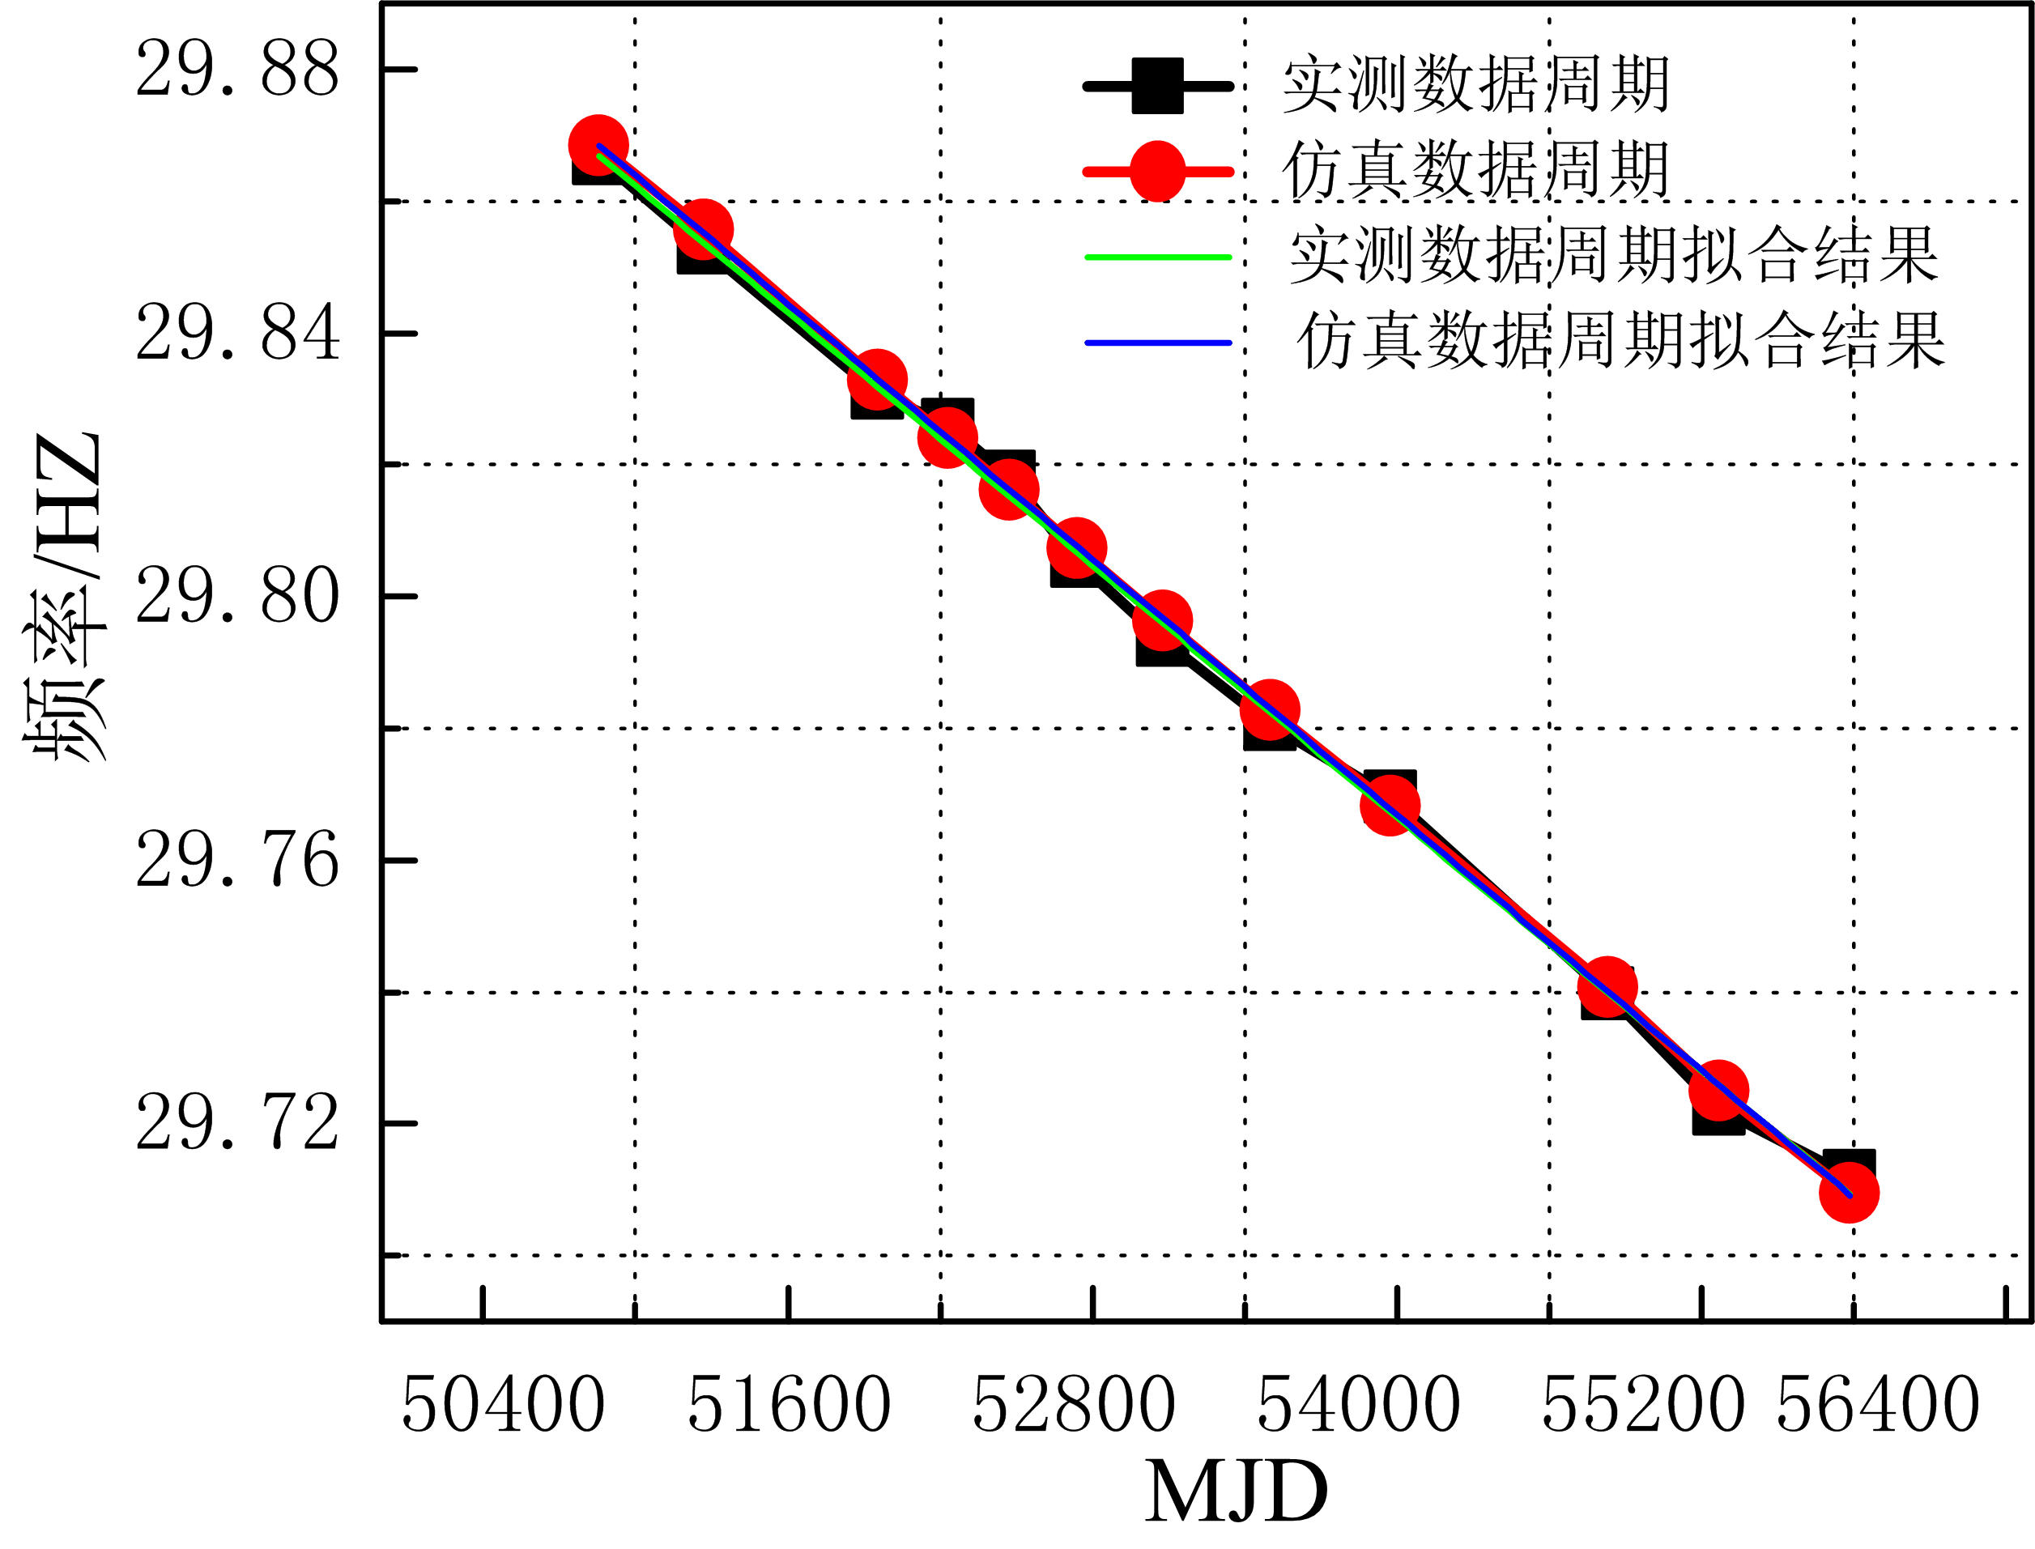
图3 Crab脉冲星仿真和实测数据周期拟合结果
（3）脉冲星不同能级轮廓特性验证。本文首先仿真了Crab脉冲星2-5keV的光子到达时间序列，该能级平均流量为0.8 ph/cm²s，仿真时长700s，探测器面积为1000cm²。然后对该序列进行轮廓累积，并与该能级实测数据所产生的标准轮廓进行比较，结果如图4(a)所示，图4(b)为仿真的带噪脉冲星信号累积轮廓和标准轮廓的比较结果。
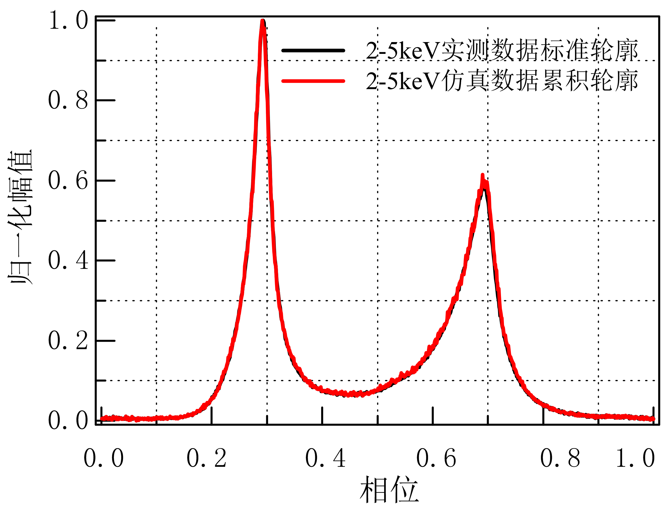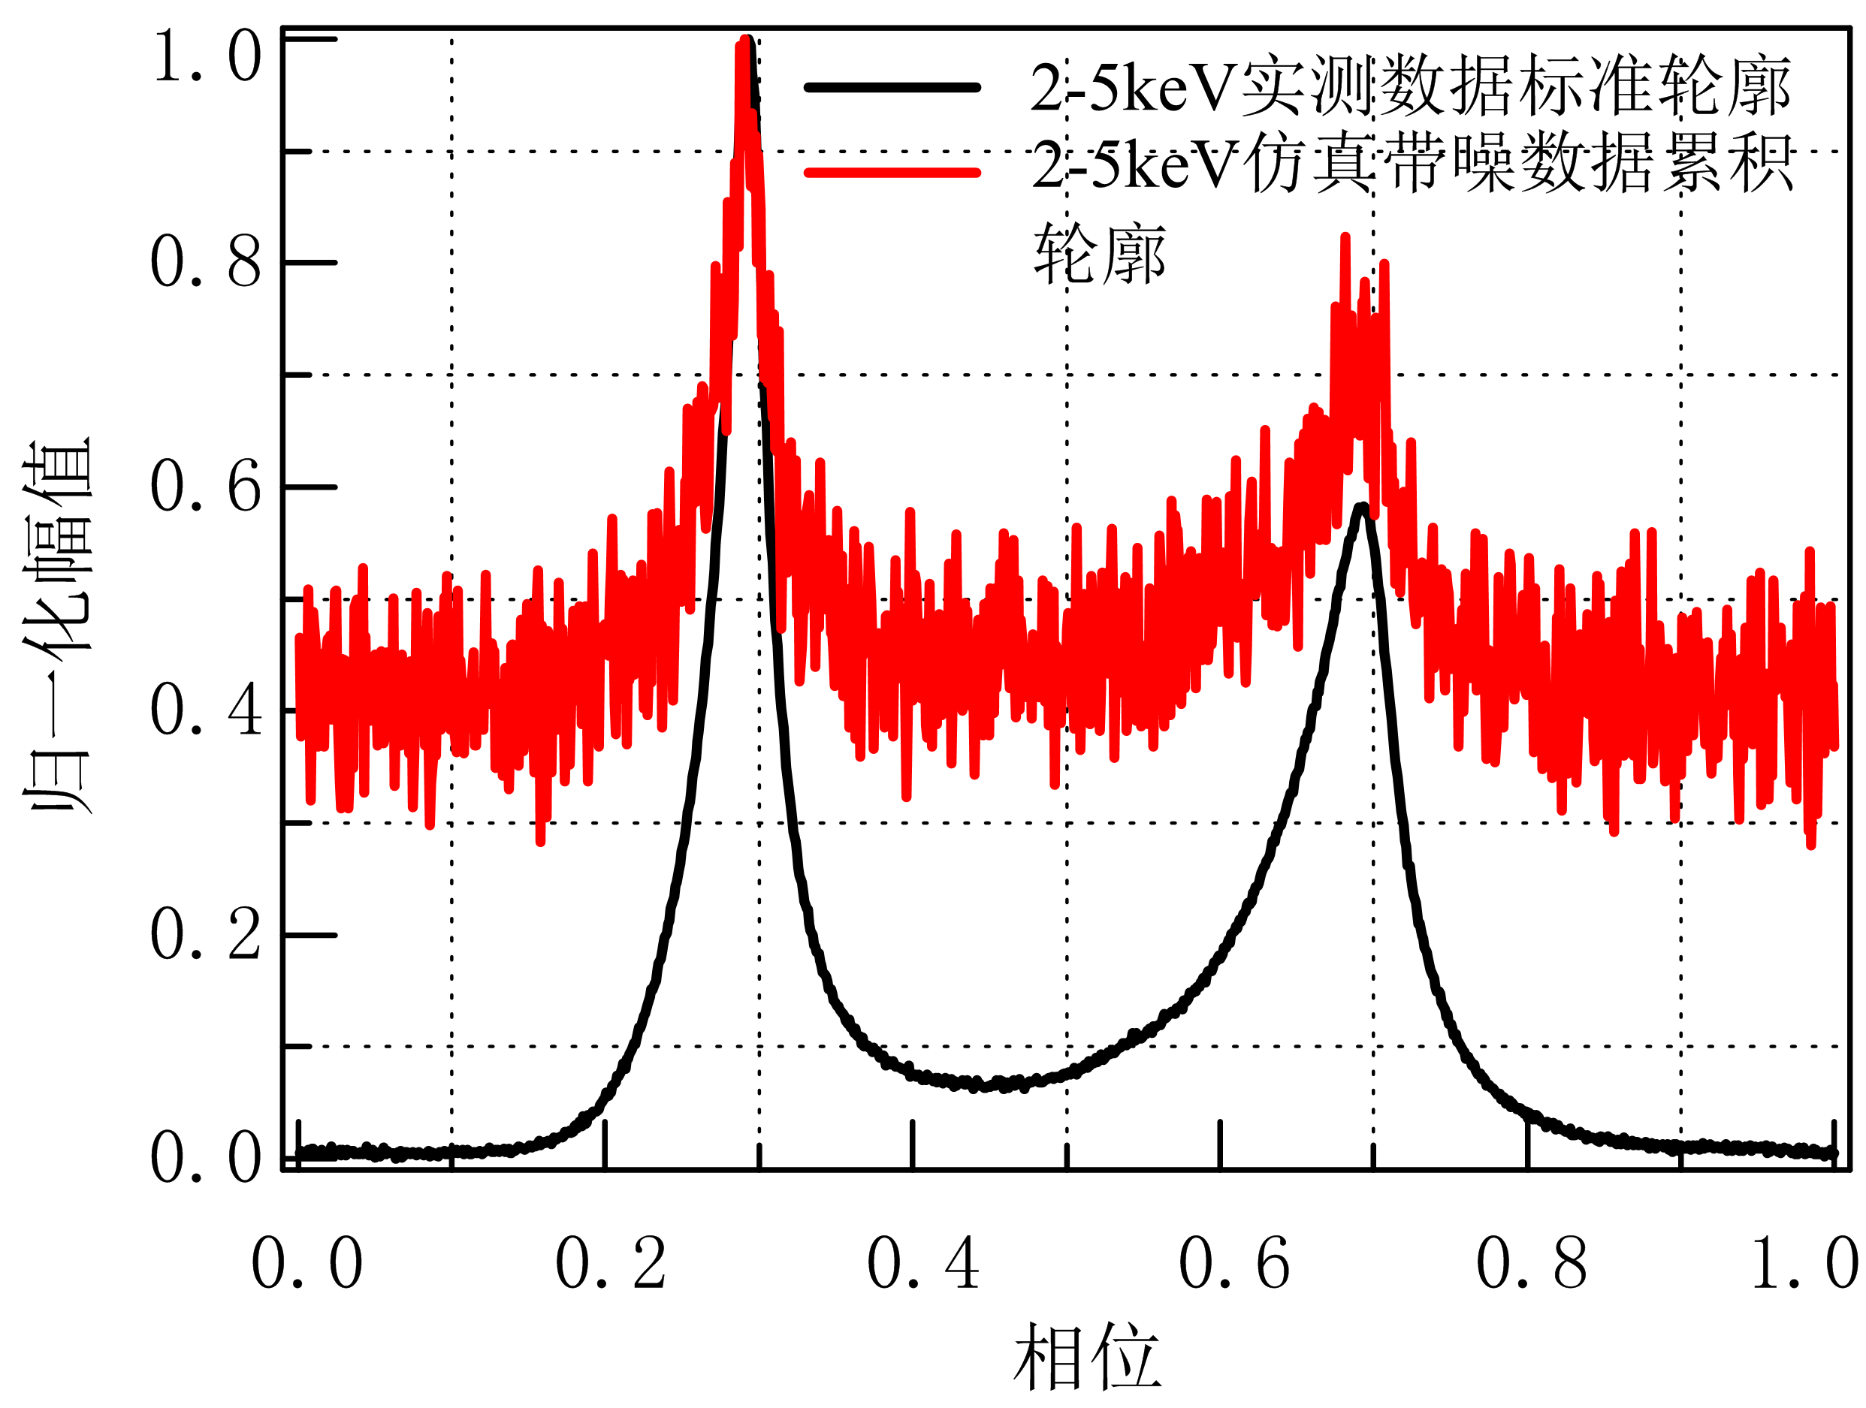
（a）不带噪仿真数据累积轮廓与标准轮廓对比（b）带噪仿真数据累积轮廓与标准轮廓对比
图4 Crab脉冲星2-5keV能级的实测数据标准轮廓与仿真数据累积轮廓的对比
从图4可以看出，仿真信号累积轮廓和该能级的标准轮廓能够完全匹配，加噪声后脉冲轮廓尖锐程度变差，出现了明显的直流抬升，而且轮廓形状和信噪比都有明显变化，这些变化都与实际情况相吻合^{[11]}。为比较各个能级仿真数据累积轮廓和标准轮廓的相关度，本文仿真了不同能级的光子序列，其累积轮廓和相应能级标准轮廓之间的比较结果如表2所示。
表2 Crab脉冲星不同能级标准轮廓和仿真光子序列累积轮廓比较
能级 | 2-5 keV | 5-9 keV | 9-13 keV | 13-17 keV | 17-22 keV | 22-60 keV
皮尔逊相关系数 | 0.9994 | 0.9994 | 0.9993 | 0.9992 | 0.9985 | 0.9987
从表2不同能级轮廓对比可以看出，本仿真方法产生的光子序列累积轮廓与标准轮廓的皮尔逊相关系数均大于0.99，验证了本方法可实现脉冲星不同能级轮廓光子序列的高精度仿真。
（4）X射线宇宙背景噪声特性验证。本文选择观测号为96801-01-22-10的实测噪声数据包，对其进行数据分析，结果表明宇宙背景噪声光子到达时间服从泊松分布，强度为101.9，到达时间间隔服从指数分布，背景噪声光子历元折叠后的光子数幅值服从高斯分布。根据实测数据先验信息，本文仿真产生了该数据包的背景噪声光子序列，仿真时间为1261s，然后统计了仿真的光子到达时间间隔及光子数幅值分布特性，结果如图5所示。
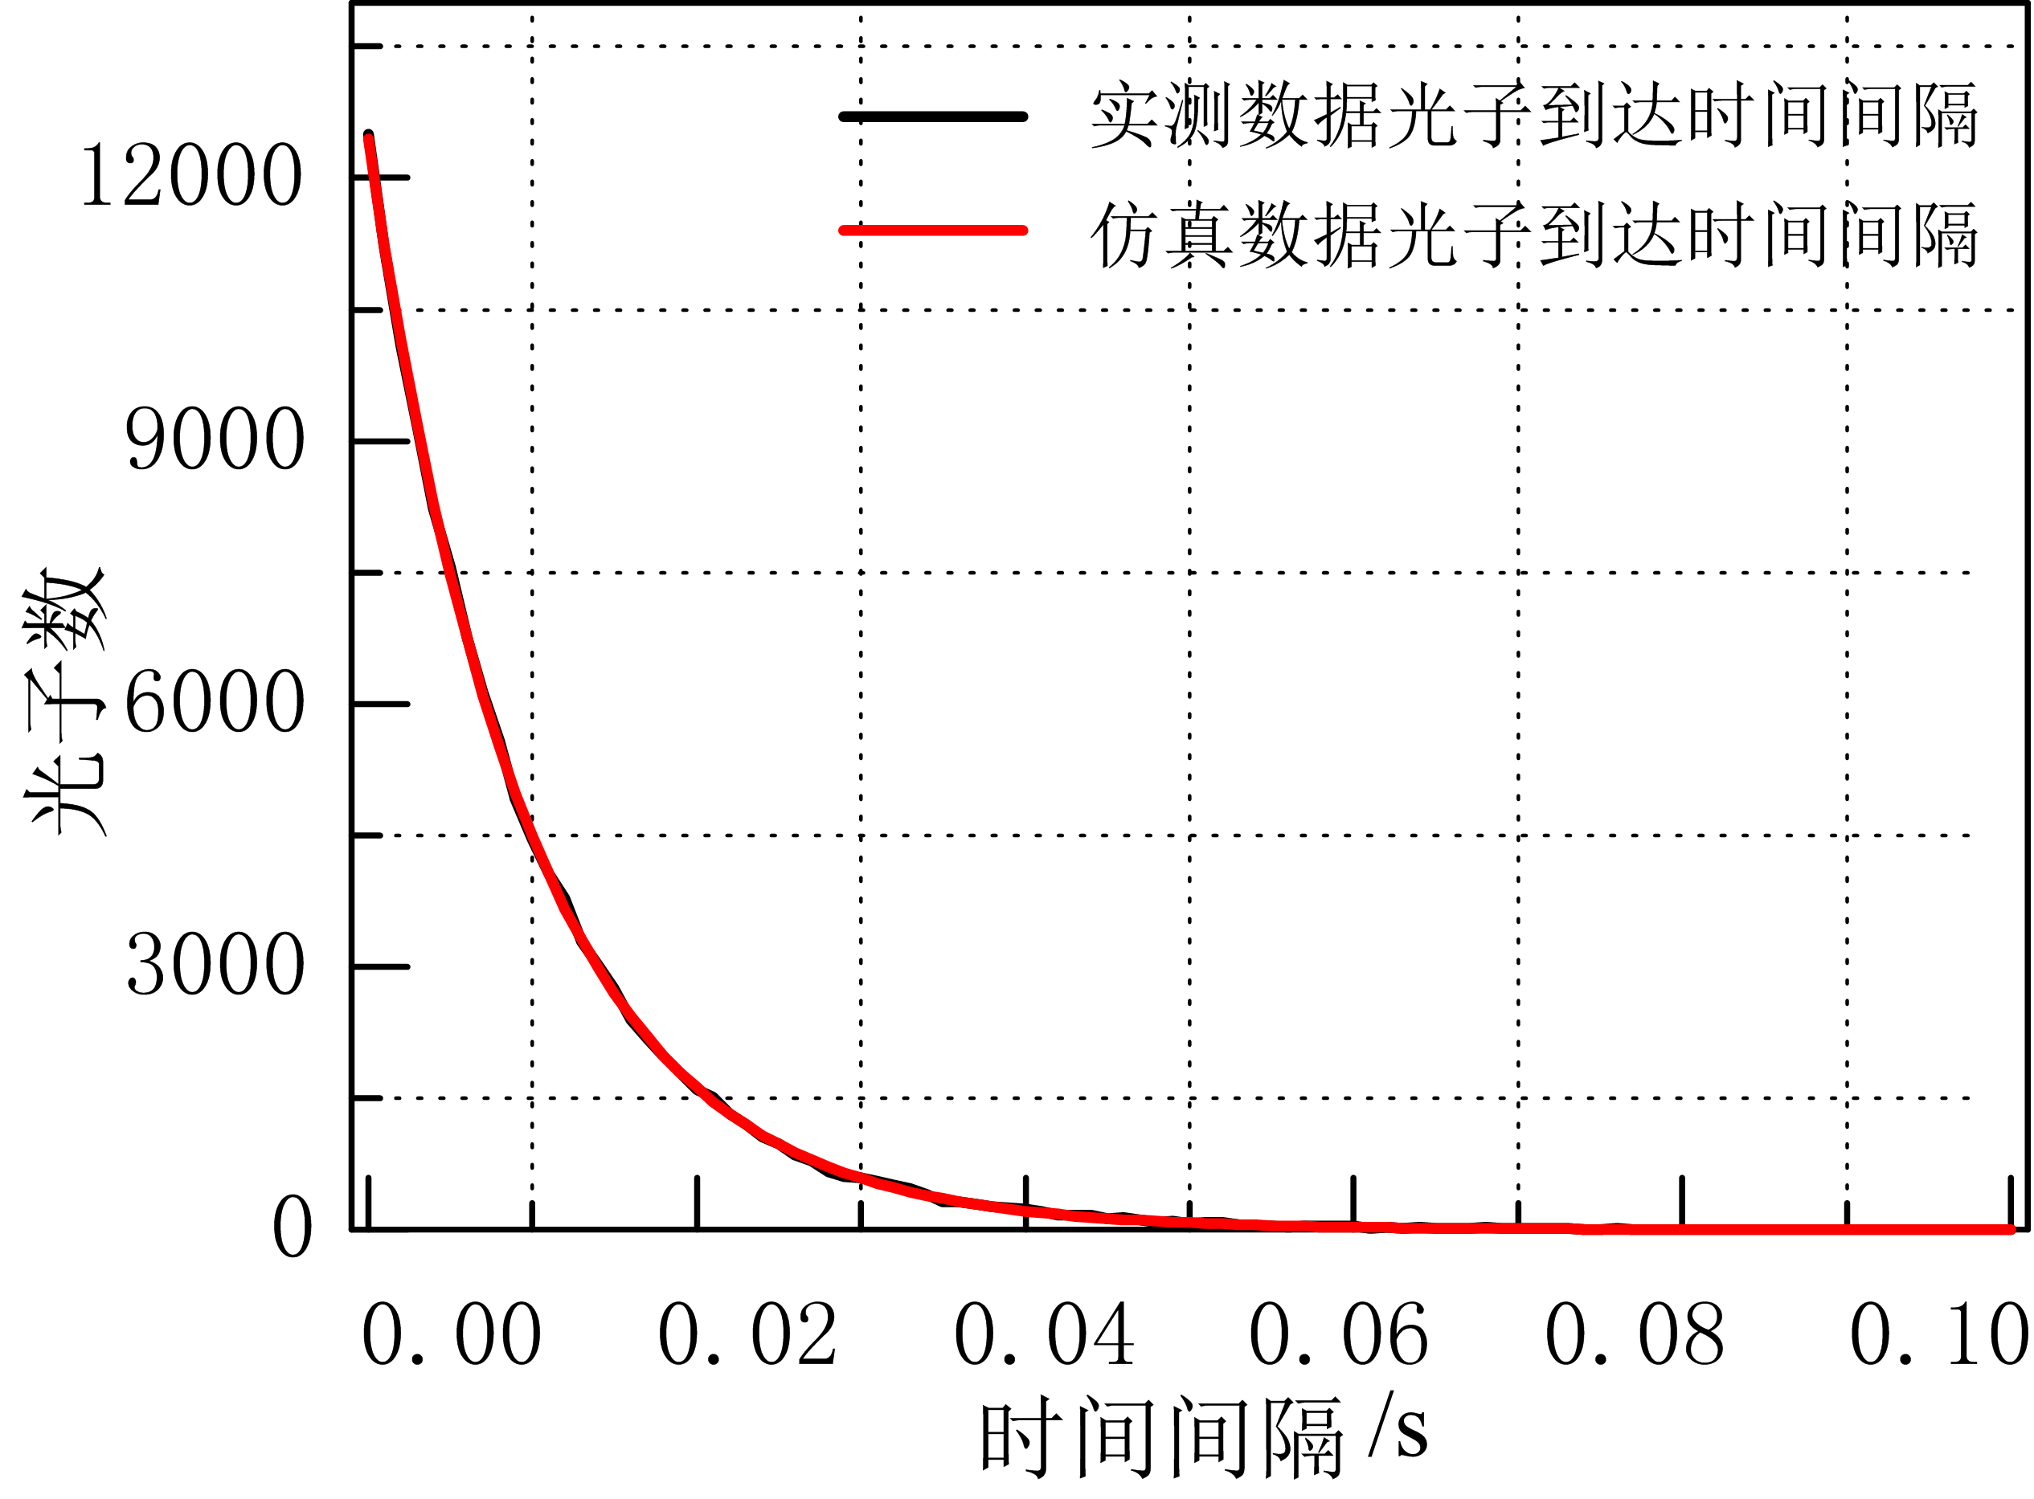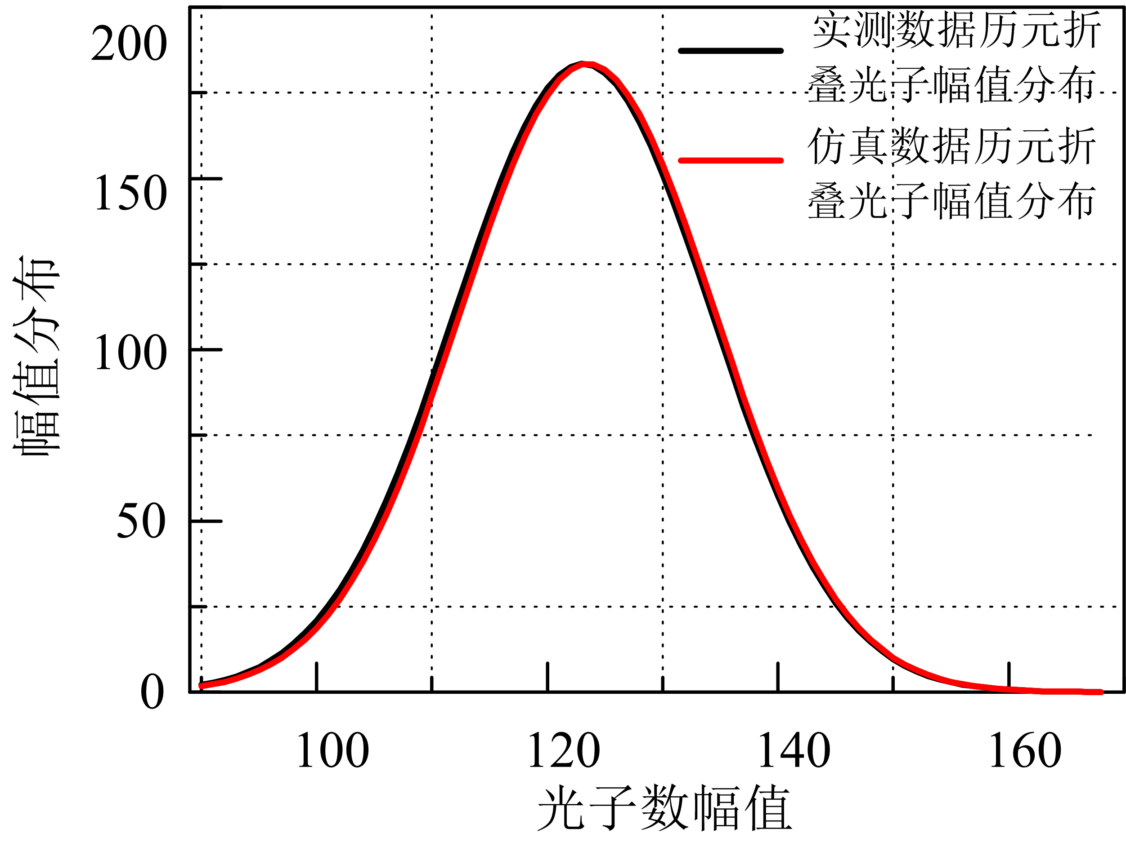
（a）光子到达时间的间隔分析（b）噪声幅值的分布特性
图5噪声光子到达时间的间隔及噪声幅值的分布特性
从图5（a）的仿真噪声间隔分布可以看出，仿真产生的光子序列间隔服从指数分布且与实测噪声数据的光子到达时间间隔非常吻合。仿真噪声光子历元折叠后的光子数幅值分布呈现高斯分布特性（如图5（b）所示），这与实测数据的统计结果完全一致，说明本仿真方法可有效的仿真X射线宇宙背景噪声特性。
- 结论
本文以RXTE卫星实测数据物理特性为先验信息，研究了一种航天器处具有多物理特性的脉冲星信号仿真方法，设计和实现了具有多物理特性的脉冲星信号仿真软件。通过仿真与实测数据比较可得出如下结论：本仿真方法采用10us时间转换模型对仿真产生的SSB处光子到达时间进行转换，得到的航天器处仿真数据与实测数据之间的误差仅为10⁻⁷s，满足精度要求；仿真与实测数据的周期变化趋势仅有0.93%的误差；不同能级仿真数据与实测数据轮廓的皮尔逊相关系数达到0.99以上；同时，本仿真方法还可实现空间不同位置处宇宙X射线背景噪声的仿真，其噪声到达时间间隔服从指数分布，噪声光子数幅值服从高斯分布，这些性质都与实测数据相符，表明了本仿真方法的有效性和可行性。所以本文方法可实现航天器处连续、有效、高精度的具有多物理特性的脉冲星信号仿真，这些数据可为X射线脉冲星导航提供连续、有效的数据支撑，解决目前我国脉冲星数据量不足，数据不连续的问题。
参考文献
[1] Taylor Jr, Joseph H. Millisecond pulsars: Nature's most stable clocks [J]. Proceedings of the IEEE. 1991, 79(7):1054-1062.
[2 ] Sheikh S I. The use of variable celestial X-ray sources for spacecraft navigation [D].University of Maryland, USA，2005.
[3]Emadzadeh A A, Speyer J L. On modeling and pulse phase estimation of x-ray pulsars [J]. IEEE Transactions on Signal Processing. 2010, 58(9): 4484-4495.
[4] Gruber D E, Blanco P R, Heindl W A, Pelling M R, et al. The high energy X-ray timing experiment on XTE[J]. Astronomy Astrophysics, 1996, 120:641.
[5] Weisskopf M C. The Chandra X-Ray Observatory:An overview [J]. Advances in Space Research, 2003,32(10): 2005-2011.
[6] 孙守明.，基于 X 射线脉冲星的航天器自主导航方法研究[D].国防科学技术大学, 2011.
[7] 孙海峰，谢楷，李小平等，高稳定度X射线脉冲星信号模拟[J].物理学报. 2013(10): 518-528.
[8] 苏哲,X射线脉冲星导航信号处理方法和仿真实验系统研究[D].西安电子科技大学，2011.
[9]Shen LR, Li XP et al. A novel period estimation method for X-ray pulsar based on frequency subdivision [J] Frontiers of information
Technology&Electronic Engineering, 2015,16(10):858-870.
[10]Fu LZ, Shuai P et al. The research of X-ray pulsar signals simulation method. 2015 China Satellite Navigation Conference (CSNC) Proceedings: Volume III, Lecture Notes in Electrical Engineering 342, Xi’an, China, 2015, May 13-15, P635-647.
[11] 刘秀平，李小平，孙海峰,等, 利用Bayesian多尺度模型的x射线脉冲星信号估计[J],西安电子科技大学报,2013,40(4):90-9

In the rest of this paper, MOPSO/D is used to denote a general multi-objective particle swarm optimizer while not the specific algorithm proposed by Peng and Zhang.
The jMetal framework [12] is used to implement cMOEA/D and OMOPSO. D2MOPSO is implemented by its author. cMOPSO/D-P and cMOPSO/D-LO are implemented by the authors of this paper.

